Name Class Date

Language focus
1 Complete the sentences with the correct form of be going to.
0 Ben isn’t going to see his friends tonight. (–)
- My brother study at university next year (+)
- Mum and Dad book our holiday tomorrow. (+)
- We go to Clara’s party next Saturday. (–)
- Brad and Julia get married next year. (+)
- Jack finish his project now. (–)

5

2 Complete the sentences with the correct form of will and the verbs in brackets.
0 Will you help (you / help) me with my homework at the weekend?
- Sam (not come) with us to the skate park.
- We (leave) at 10.00 am tomorrow.
- I (not be) at football practice tomorrow.
- I think I (have) a sandwich for lunch.
- (Max / do) well in the competition next week?

5

3 Match the questions (1–5) with the answers (a–f).
0 Will you be at school tomorrow? f a Yes, I am.

- Are you going to play football, Ben?
b Yes, she is.

- Are you and Paul going to organise a school party? c No, we aren’t.

- Will the weather be nice tomorrow?
d Yes, they are.

- Are your parents going to buy a new car? e No, it won’t.
- Is Maria going to do her Geography homework? f Yes, I will.

5

4 Choose the correct answer: a, b or c.
0 I think to see my cousin today.
a going b to go
- What time meet Mark?

I’ll go
c

a are you going b you are going to c are you going to
- A: Are you going to help me with my homework?
B: No, .
a I’m not going b I’m not c I won’t
- I’m sure you have a great time on holiday!
a going to b will c are going
- A: Is Nick going to visit England this year?
B: Yes, .
a he will b he does c he is
- Chloe and Tom going to buy anything in town tomorrow.
a aren’t b don’t c won’t

5

Vocabulary

Label the pictures.

It’s foggy. It’s windy. It’s rainy. It’s snowy. It’s icy. It’s sunny.

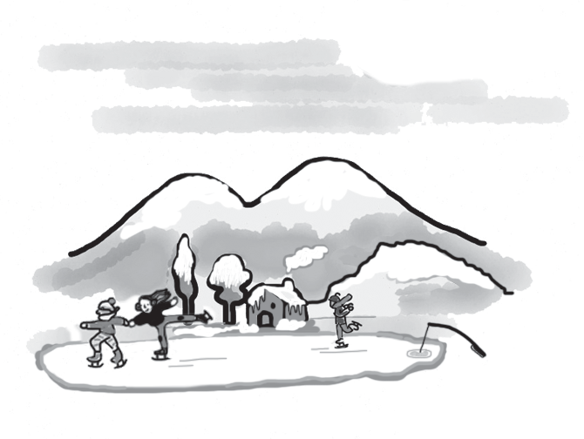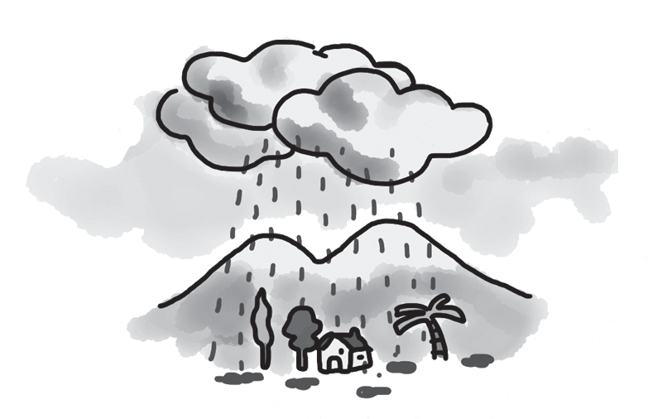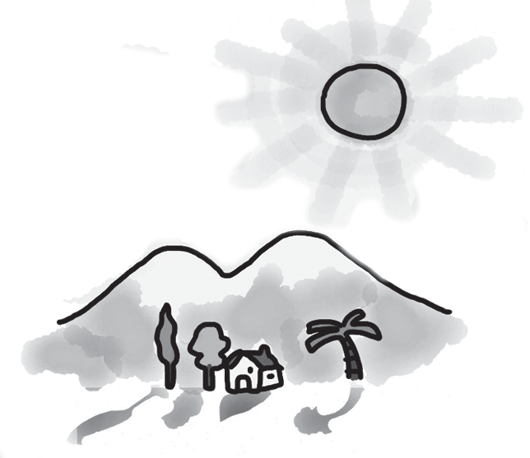
0 It’s icy. 1 2

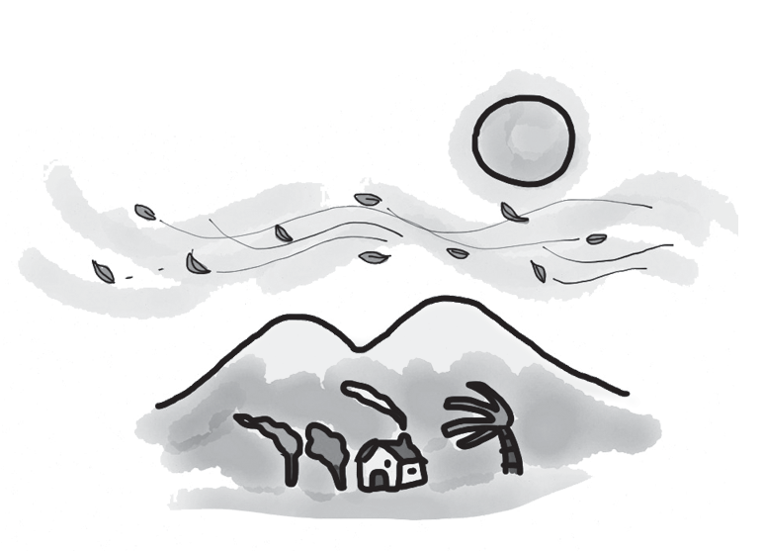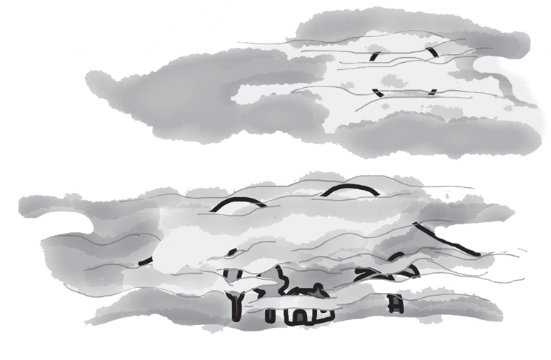

3 4 5

5

Complete the words about the landscape. The first letter is there to help you. There is one space for each other letter in the word.
0 You can go skiing here in the winter. m o u n t a i n s
- This is a place with lots of trees. f
- Many wild animals live here. j
- There aren’t many trees here because it’s very dry. d
- This place is very near the sea. b
- You can walk up to the top of this to take some good photos. h

5

Choose the correct answer: a, b or c.
Last year, my family and I 0 on holiday to Australia to see my cousins. It was a really 1 trip! We 2 three weeks there, and we saw so many different places. We 3 in a cabin in the trees. It was a very 4 place, so there were a lot of people there. We went to museums and restaurants, did some sport and saw lots of animals. But we had one problem – we forgot to
5 summer clothes with us. It was boiling hot!

0 | a | went | b | visited | c | had
1 | a | usual | b | amazing | c | typical
2 | a | lived | b | spent | c | passed
3 | a | moved | b | made | c | stayed
4 | a | popular | b | enormous | c | great
5 | a | put | b | get | c | take

5

Choose the correct answer: a, b or c.
0 It’s often icy in in Europe.
a
winter b summer c autumn
- It’s not a good idea to go windsurfing when it’s .
a sunny b windy c stormy
- There aren’t many fish in the in our town.
a river b hill c beach
- On a luxury city holiday, people usually stay in a wonderful .
a cabin b tree house c hotel
- I want to go snowboarding in the for my next holiday.
a desert b mountains c jungle
- I often cycle to the top of the behind my house because there are great views.
a forest b lake c hill

5

Useful language

Complete the conversation between Samantha and her dad. What does Samantha say to her dad? Choose from the answers (a–g). There is one more answer than you need.

Dad: Where shall we go on holiday this year, Samantha?
Samantha: 0 d
Dad: What about a summer camp? You went last summer.
Samantha: 1 Dad: Why not? Samantha: 2
Dad: Yes, that’ll be nice. What can we do there?
Samantha: 3
Dad: Right, that’s a good idea.
Samantha: 4
Dad: That’s OK, Samantha. Now, shall we drive or go by train?
Samantha: 5
Dad: Yes, you’re right. Fine.
  - I think it’ll be better to travel by car.
  - I didn’t really like it. Let’s go to the beach!
  - Yes, it is. Thanks, Dad!
  - I don’t know, Dad.
  - Well, there’s surfing and swimming …
  - It’s going to be perfect!
  - I’d prefer not to go there again, Dad.

5




Listening

Listen to Katie telling Josh about her holiday plans. Are the statements True (T) or False (F)?

0 | Katie is going to visit Australia with her mum. | T
1 | Katie’s aunt lives in Australia.
2 | Katie wants to go windsurfing in Australia.
3 | Katie is going to stay in a luxury hotel in Australia.
4 | Katie likes buying things.
5 | Katie’s going to be away for three weeks.

15

Reading

Read about a place to go on holiday.


Home
About
Posts
Hi! My name’s Anna, and I want to tell you about my family holidays. Every summer,
and sometimes in the winter, I go with my parents and two brothers to a holiday resort in the south of our country, near the sea and not very far from the mountains. The resort is very popular because it has beautiful landscapes, and there’s usually a lot to do.
And on the days when it’s a bit rainy, we’re happy to just sit and read or listen to music. It’s the perfect place to go on holiday.
There are many interesting places to visit in the town there. For anyone in your family that likes history, there are a lot of museums and ancient houses. When the weather is good, you can walk along the streets and enjoy the outdoor cafés. And you can buy anything you want at the new shopping centre – it’s enormous!
We usually stay in a hotel, but there are good hostels there, too, or cabins in the forest outside the town.
In the winter, there are many places where you can go skiing, and in the summer there are excellent places to go cycling. I’m sure that anyone who goes there will have a brilliant holiday!

Are the sentences True (T) or False (F)?

0 | There are four people in Anna’s family. | F
1 | A lot of people like going to the same resort as Anna.
2 | Anna doesn’t like days when there’s bad weather there.
3 | Anna says the new shopping centre is quite small.
4 | There are places for visitors to stay in the forest.
5 | Anna says there are things for visitors to do all year.

15

Writing

Write about your next holiday. Use the questions to help you.


Where are you going to visit? Who are you going to travel with?
How long are you going to stay there? Where are you going to stay?
What are you going to do there?

Write 25–35 words.

15

90

Thanks and acknowledgments

We would like to thank the following for their contributions:
Sue Elliot for adapting the tests; Sarah Ackroyd & Nick Coates (Speaking) for writing the tests; Bartosz Michalowski for content and copy editing; and Jeff Zrobak for editing of proofs.

The authors and publishers are also grateful to the following contributors:
emc design ltd: develop concept design, text design and layouts Ian Harker & DSound: audio recordings
The authors and publishers acknowledge the following sources of copyright material and are grateful for the permissions granted. While every effort has been made, it has not always been possible to identify the sources of all the material used, or to trace all copyright holders. If any omissions are brought to our notice, we will be happy to include the appropriate acknowledgements on reprinting.

The publishers are grateful to the following illustrators: Anni Betts: Unit 8 Test: Standard, p. 2 (5); Maria Luisa Rivero: Unit 8 Test, Student A & Student B; Unit 8 Test: Standard, p. 2 (0, 1, 2, 3, 4).

