Name Class Date

Language focus

1 | Complete the answers to the questions.  0 Did Sam go into town yesterday? | No, he didn’t .
 | 1 Did you and Ben do drama after school? | Yes, we .
 | 2 Did you know the answer, Sarah? | No, I .
 | 3 Did your grandparents have dinner with you? | Yes, they .
 | 4 Did your sister study at the weekend? | No, she .
 | 5 Did your brother go to the skate park yesterday? | Yes, he .

5

2 Put the words into the correct order to make questions.
0 Jack / to / did / When / town / go?
When did Jack go to town?
- go / time / did / bed / to / What / you
?
- yesterday / Where / Sally / her / meet / did / friends
?
- did / When / tennis / start / you / playing
?
- go / on / did / Where / holiday / Ben
?
- TV / What / watch / night / you / last / did / on
?

5

3 Complete Peter’s questions using the words in brackets.

0 | Peter: | What did you do (do) yesterday, Tim?
 | Tim: | I played a game of football.
1 | Peter: | Who (play) football with?
 | Tim: | I played with my classmates.
2 | Peter: | Where (go) to play?
 | Tim: | We went to the sports centre.
3 | Peter: | How (get) there?
 | Tim: | We got there by bus.
4 | Peter: | And how many goals (score)?
 | Tim: | We didn’t score any goals. We lost!
5 | Peter: | Oh! What time (get) home?
 | Tim: | I got home at 5 o’clock.

5

4 Choose the correct answer: a, b or c.
0 Where Jack’s family go on holiday last week?
c

3 A: How did you get to school last week?

a does b do
1 A: Did you watch TV yesterday?
B: Yes, .
did
B: .
a By bus b At 8.30 am c On Thursday
4 did you get up this morning?

a I was b I have c I did
2 forget your mum’s birthday?
a Did you b Were you c Had you
a What b What time c Where
5 What on Saturday?
a did you b you did c did you do

5

Vocabulary
5 Complete with play or go.
0 go swimming
- tennis
- surfing

- basketball
- skiing
- volleyball

5

Complete the sentences with a sport from the box.

windsurfing baseball bowling judo skateboarding cycling

0 I really want to go skateboarding at the new park in our town.
- I often go on the sea with my family.
- We went last weekend, and I fell off my bike!
- My brothers both play with their friends every week, and they’re in the school team.
- My sister does in the sports hall. She wears a special jacket and trousers.
- Ben went with his friends at the alley in town yesterday.

5

Label the pictures.

trousers hoodie shorts skirt tracksuit boots

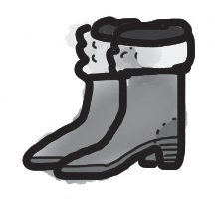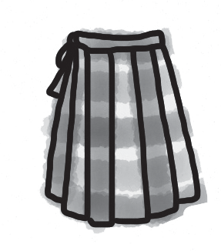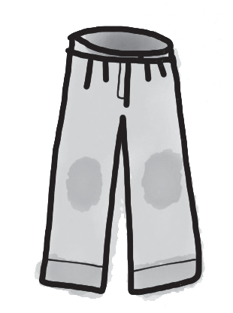
0 boots 1 2

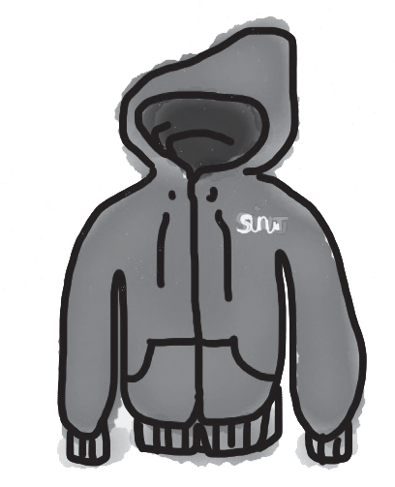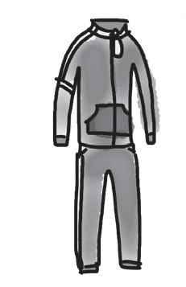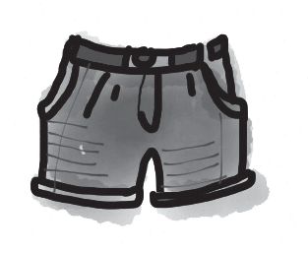
3 4 5

5

8 Choose the correct answer: a, b or c.
b
0 I generally play at the sports centre.

3 I never go because I don’t like the pool in town.

a bowling
basketball c surfing
a surfing b swimming c skateboarding

- I always wear big boots and warm on my feet for skiing.
a caps b jeans c socks
- Are you cold? You’re only wearing a and jeans.
a T-shirt b tracksuit c sweatshirt
- I don’t go in the city because there are a lot of cars on the roads.
a skiing b windsurfing c cycling
- I bought some nice summer yesterday.
a shorts b boots c hoodies

5

Useful language

9 Complete the conversation between Anna and Jack. What does Anna say to Jack? Choose from the answers (a–g). There is one more answer than you need.

Jack: Hi, Anna! How are you?
Anna: 0 c
Jack: So what did you do at the weekend?
Anna: 1
Jack: Cool! How was it?
Anna: 2
Jack: Great! But was it easy?
Anna: 3
Jack: Oh, no! Why? What happened?
Anna: 4
Jack: Really? I’m sorry.
Anna: 5
Jack: Good! It sounds wonderful!
  - No, it was quite hard.
  - Oh, it’s OK. I want to go again!
  - Fine, thanks, Jack!
  - It was amazing!
  - I fell a lot!
  - That was quite interesting.
  - I went snowboarding for the first time.

5




Listening

Listen to five people talking about sport. Which sport is each speaker describing? Choose the correct answer: a, b or c.

0 | Example
 | a tennis | b | bowling | c | cycling
1 | Speaker One
 | a snowboarding | b | windsurfing | c | skateboarding
2 | Speaker Two
 | a cycling | b | skiing | c | surfing
3 | Speaker Three
 | a judo | b | volleyball | c | tennis
4 | Speaker Four
 | a basketball | b | skiing | c | judo
5 | Speaker Five
 | a snowboarding | b | skiing | c | skateboarding

15

Reading

Read this article on the London 2012 Olympics.



The 2012 Summer Olympics took place 0 London and the south of England from 27 July until 12 August. Before 1 started, most people 2 think that the Games would be very good. People also weren’t happy that the Games were so expensive. But after they finished, everyone that 3 sport said that they were fantastic!
Over 10,000 athletes came to London from all over the world, and there were more 4 7 million tickets to see the different sports: tennis, judo, swimming, cycling, football, windsurfing and many more. There really was 5 sport for everyone!
Complete the text. Choose the correct answer: a, b or c.

0 | a on | b | at | c | in
1 | a it | b | they | c | this
2 | a weren’t | b | don’t | c | didn’t
3 | a liking | b | like | c | liked
4 | a than | b | that | c | then
5 | a any | b | the | c | a

15

Writing

Write about the sports you like doing. Use the questions to help you.


What sports can you do in your town? What sports do you like doing?
Where do you do them?
What sports do you like watching on TV?

Write 25–35 words.

15

90

Thanks and acknowledgments

We would like to thank the following for their contributions:
Sue Elliot for adapting the tests; Sarah Ackroyd & Nick Coates (Speaking) for writing the tests; Bartosz Michalowski for content and copy editing; and Jeff Zrobak for editing of proofs.

The authors and publishers are also grateful to the following contributors:
emc design ltd: develop concept design, text design and layouts Ian Harker & DSound: audio recordings
The authors and publishers acknowledge the following sources of copyright material and are grateful for the permissions granted. While every effort has been made, it has not always been possible to identify the sources of all the material used, or to trace all copyright holders. If any omissions are brought to our notice, we will be happy to include the appropriate acknowledgements on reprinting.

The publishers are grateful to the following illustrators: Maria Luisa Rivero: Unit 7 Test: Standard, p. 2.

