Name Class Date

Language focus

1 Complete the answers to the questions.
0 Did Sam spend any money in town yesterday? No, he didn’t .
- Did you and Tom play football after school? Yes, .
- Did you know the answer, Sarah? No, .
- Did your parents go to the cinema on Saturday? Yes, .
- Did your sister go swimming on holiday? No, .
- Did your granddad like his birthday present? Yes, !

5

2 Write complete questions in the past simple.
0 Ben / go / to town / at the weekend?
Did Ben go to town at the weekend?
- When / you / do / your homework / yesterday
?
- What time / the English lesson / finish / this morning
?
- When / you / start / playing tennis
?
- What / Tom / buy / for / his mum
?
- Where / Sam / go on holiday
?

5

3 Complete the questions with the words in brackets.
0 Did you practise a lot for the football game? (you / practise)
- a lot of money in town yesterday? (Sam / spend)
- a film on TV last night? (your parents / watch)
- football yesterday? (Sarah / play)
- hard for the exam? (you and Tom / study)
- a birthday present for your sister? (you / buy)

5

Choose the correct answer: a, b or c.
Hi Sarah,
0 you busy last weekend? 1 your homework last Saturday? I 2 finished my homework then because I was very busy. I watched a tennis match on TV. It was great! I know you went to the cinema on Sunday. 3 did you see? Tell me all about it! 4 a good time? I hope so. And 5 go with?
Write soon! Maria
0 | a | Was | b | Had | c | Were
1 | a | Did you | b | Did you do | c | Do you do
2 | a | didn’t | b | doesn’t | c | don’t
3 | a | When | b | What | c | Where
4 | a | Had you | b | Did you | c | Did you have
5 | a | who you | b | who did you | c | who did
5

Vocabulary
- Complete the sentences with play, do or go.
0 Did you play football on your last holiday?
- Where did you tennis yesterday?
- We surfing in the sea every summer because it’s not cold.
- Did you judo last Saturday morning?
- I don’t swimming in the pool in town because the sea is better.
- Sam doesn’t often baseball at the weekend.

5

Fill in the missing words. The first letter is there to help you.
0 I often go snowboarding when it’s cold. I prefer it to skiing.
- Ben sometimes goes w on the sea near his home.
- There’s a good b team at school. All the players are very tall.
- I started j lessons last year. My partner is very good, so I can learn a lot from him.
- I often go b with my friends at the new alley in town.
- We go c every weekend. I have an old bike, but my brother’s is new so he goes very fast.

5

Label the pictures.

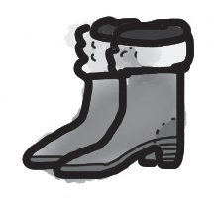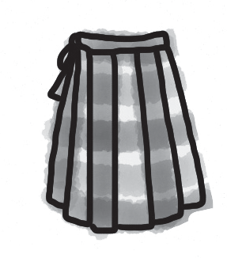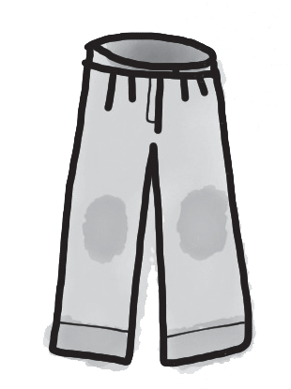
0 boots 1 s 2 t

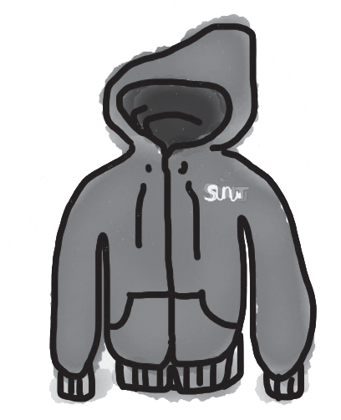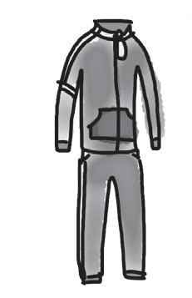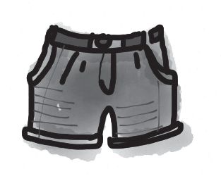
3 h 4 t 5 s

5

0 | a | tracksuit | b | jacket | c | skirt
1 | a | child | b | children | c | people
2 | a | goes | b | does | c | plays
3 | a | surfing | b | cycling | c | skateboarding
4 | a | boots | b | shorts | c | trousers
5 | a | judo | b | cycling | c | volleyball

Choose the correct answer: a, b or c.
Hi! I’m Sarah, and I love sport. I usually wear a 0 when I’m not at school! My sister and I started skiing when we were young 1 , so our family usually 2 skiing in the winter holidays. We have cousins in Switzerland, and it’s a traditional sport there.
In the summer, my sister and I love 3 in the sea. And this year I want to buy some new 4
because I want to start playing 5 on the beach.

5

Useful language

Complete the five conversations. Choose the correct answer: a, b or c.

0 | What clothes did you buy? | a | That’s right.
 |  | b | Yes, I did.
 |  | c | Some new trousers.
1 | I went snowboarding for the first time. | a | How was it?
 |  | b | Were you?
 |  | c | Why not?
2 | I fell off my bike. | a | Can you do it?
 |  | b | Really? I’m sorry.
 |  | c | That was amazing!
3 | What happened on your skiing lesson? | a | I had some problems.
 |  | b | It was easy.
 |  | c | It’s OK.
4 | How was windsurfing? | a | £7.50 for the class.
 |  | b | I loved it!
 |  | c | At the sports centre.
5 | What did you do at the weekend? | a | It sounds fantastic!
 |  | b | What do you usually do?
 |  | c | I learned something new!

5




Listening

Listen to five people talking about sport. Which sport is each speaker describing? Choose from the box. There are more names of sports than you need.

tennis swimming judo bowling volleyball skateboarding cycling windsurfing snowboarding skiing

0 Example bowling
- Speaker One
- Speaker Two
- Speaker Three
- Speaker Four
- Speaker Five

15

Reading

Read this article on the 2012 Olympics.


The 2012 Summer Olympics took place 0 London and the south of England from 27 July until 12 August. Before they started, most people didn’t think that the Games would be
very 1 . People also weren’t 2 that the Games were so expensive. But after they 3 , everyone that liked sport said that they were fantastic!
Over 10,000 athletes came to London from all over the world, and there were more 4 7 million tickets to see the different sports: tennis, judo, swimming, cycling, football, windsurfing and 5 others. There really was a sport for everyone!
Complete the text. Choose the correct answer a, b or c.

0 | a | in | b | on | c | at
1 | a | good | b | funny | c | usual
2 | a | lucky | b | happy | c | brilliant
3 | a | finishing | b | finish | c | finished
4 | a | than | b | that | c | then
5 | a | much | b | lots | c | many

15

Writing

Read the email from your English-speaking friend, Ian.

From: Ian
To:

I really love sport! Do you? What sports do you like doing? When did you last do some sport? Where can you do sport in your town?

Write an email to Ian and answer the questions. Write 40–50 words.

15

90

Thanks and acknowledgments

We would like to thank the following for their contributions:
Sue Elliot for adapting the tests; Sarah Ackroyd & Nick Coates (Speaking) for writing the tests; Bartosz Michalowski for content and copy editing; and Jeff Zrobak for editing of proofs.

The authors and publishers are also grateful to the following contributors:
emc design ltd: develop concept design, text design and layouts Ian Harker & DSound: audio recordings
The authors and publishers acknowledge the following sources of copyright material and are grateful for the permissions granted. While every effort has been made, it has not always been possible to identify the sources of all the material used, or to trace all copyright holders. If any omissions are brought to our notice, we will be happy to include the appropriate acknowledgements on reprinting.

The publishers are grateful to the following illustrators: Maria Luisa Rivero: Unit 7 Test: Extra, p. 2;

