Name Class Date

Language focus

1 Underline the correct answer.
0 Was / Were it a nice day yesterday?
- I was / were at home yesterday.
- Was / Were your brothers at the party?
- A: Were you at school this morning?
B: Yes, I was / were.
- Ben wasn’t / weren’t at the park at the weekend.
- We wasn’t / weren’t late for the film on Saturday.

5

2 Complete the sentences with was, were, wasn’t or weren’t.
0 There was a good film on TV last night. (+)
- There a lot of people in town on Saturday. (+)
- There a market in our town a week ago. (–)
- there football training at school last week?
- there any car parks in our town 100 years ago?
- There any classes after school yesterday. (–)

5

Complete the text with the correct form of the verbs in brackets. Use the past simple.
I 0 had (have) a good evening on Friday. I 1 (stay) at my friend’s house after school. First we 2 (prepare) some sandwiches to eat as a snack, and then we 3 (watch) our favourite film on TV. But we 4 (not do) any homework because it was Friday! That was brilliant! We 5 (go) to bed late!

5

Choose the correct answer: a, b or c.
0 We tennis for two hours yesterday afternoon.
c

a playing b play
played

1 I a very nice meal at my grandparents’ house last Sunday.

 | a ate b eat | c eating
2 | A: Were you tired yesterday?
 | B: Yes, .
 | a I were b I was | c I did
- I a really good book last weekend.
a read b made c went
- There many cars in the street last night.
a aren’t b weren’t c wasn’t
- Jack watch television at all yesterday.
a doesn’t b wasn’t c didn’t

5

Vocabulary

Label the pictures.

sports centre bowling alley car park skate park market shopping centre

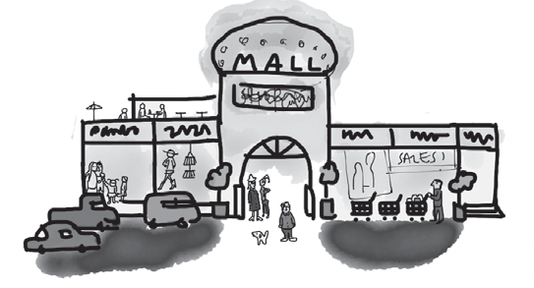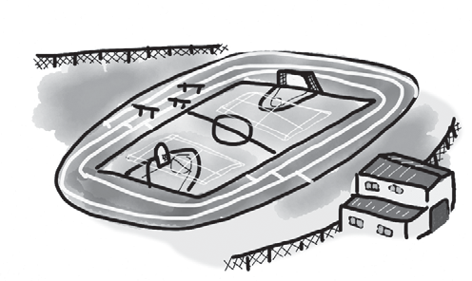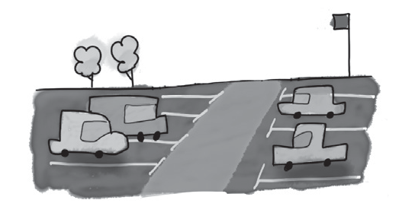
0 shopping centre 1 2

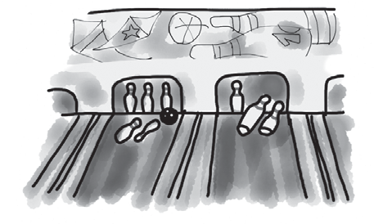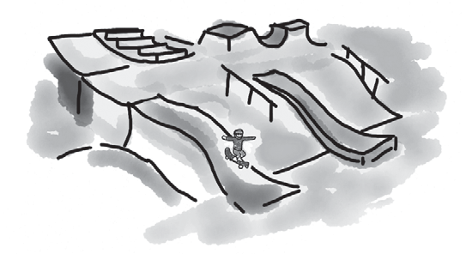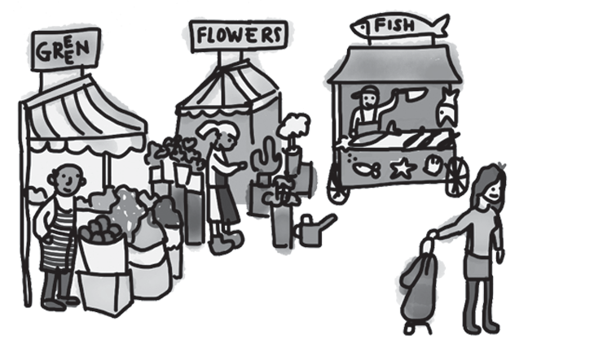
3 4 5

5

Match the descriptions (1–5) with the places (a–g). There is one more place than you need.

0 You can have lessons here. | e | a | sports stadium
1 You can watch a game of football here. |  | b | museum
2 You can buy fruit and vegetables here. |  | c | cinema
3 You can buy anything you want here! |  | d | market
4 You can watch films here. |  | e | school
5 You can look at old things here. |  | f | skate park
 |  | g | shopping centre

5

Complete the text with words from the box.

stops port station bus on ancient

A good way to see my town is to go the 0 station near the bowling alley and take a
1 to the museum. It’s enormous, with lots of interesting and 2 things to look at. Then you can go by tram to the shopping centre. There are a lot of tram 3 in town, and you can buy lots of interesting things at the centre. From there, go 4 foot to the ferry 5 . You can have dinner there in one of the wonderful cafés.
Have fun!

5

Choose the correct answer: a, b or c.
0 I sometimes go to the for some exercise after school.
c

a market b cinema
skate park

- I always go to school because I like walking.
a on foot b in a taxi c by bus
- I went to the yesterday to buy some books.
a sports centre b skate park c shopping centre
- The new sports stadium in town is very big. It’s !
a ancient b enormous c boring
- I love travelling on water, so let’s go by .
a tram b bus c ferry
- I usually buy chicken and cheese at the .
a market b museum c park

5

Useful language

Complete the conversation between Sam and Jess. What does Jess say to Sam? Choose from the answers (a–g). There is one more answer than you need.

Sam: Hi, Jess. How are you?
Jess: 0 c
Sam: Great, thanks! What did you do at the weekend?
Jess: 1
Sam: Did you? Wow! So did you know about it before?
Jess: 2
Sam: And where was the helicopter?
Jess: 3
Sam: And what did you see from the helicopter?
Jess: 4
Sam: Really? What did you do after that?
Jess: 5
Sam: I’m sure you were. That’s brilliant!
  - No, it was a birthday surprise.
  - At the airport. Dad and I got in it and off we went.
  - Fine thanks, Sam. And you?
  - It was really cool!
  - Our town – and my house!
  - I went in a helicopter!
  - Then dad took me home. I was really tired.

5




Listening

Listen to Joanna telling her friend Mark about her family’s trip to the city and what each person liked there. Match the people (1–5) with the places (a–h).
There are two more places than you need.

0 | People  Joanna | f | a | Places they liked  bowling alley
1 | Ben |  | b | café
2 | mum |  | c | cinema
3 | dad |  | d | market
4 | Becky |  | e | museum
5 | grandparents |  | f | shopping centre
 |  |  | g | skate park
 |  |  | h | sports centre

15

Reading

Read this email about Clare’s recent holiday in Prague.

Hi Rachel,
How are you? I went to Prague for a week and came back five days ago. I had a really brilliant time, and I stayed with my Czech friend, Jana. We met last year when we studied at the same school in London.
She lives in a new house near the airport, so we took the tram to the city centre every day, and then we walked around because most of the sights are in the centre. There’s an amazing museum. That was very interesting. We saw lots of old houses in the Old Town, too. There were also lots of people there because it’s such a beautiful city.
I was really excited, too, because we went to the new stadium to watch AC Sparta Prague play in a match. Jana’s brother and his friend came with us. Jana and her brother love football, and it’s their favourite team.
I really want to go back again because there are so many places I didn’t visit and next time I really want to go to the zoo!
Let’s meet up soon and I can show you my photos. Love from
Clare

Choose the correct answer: a, b or c.

0 | Clare spent in Prague.
 | a 7 days b 5 days | c | 14 days
1 | Clare first met Jana when they were together.
 | a in Prague b on holiday | c | in London
2 | Jana lives in Prague.
 | a in an old house b near the airport | c | in the centre
3 | They travelled around the city centre .
 | a in a taxi b by tram | c | on foot
4 | Clare really liked the in Prague.
 | a museum b old houses | c | people
5 | They went to the stadium to see play football.
 | a Jana’s brother b Jana’s favourite team | c | Jana’s friend

15

Writing

Write about your town. Use the questions to help you.


Where do you live?
Is your town big or small? What can you do in your town?
What are the interesting places to visit? How can you travel around your town?

Write 25–35 words.

15

90

Thanks and acknowledgments

We would like to thank the following for their contributions:
Sue Elliot for adapting the tests; Sarah Ackroyd & Nick Coates (Speaking) for writing the tests; Bartosz Michalowski for content and copy editing; and Jeff Zrobak for editing of proofs.

The authors and publishers are also grateful to the following contributors:
emc design ltd: develop concept design, text design and layouts Ian Harker & DSound: audio recordings
The authors and publishers acknowledge the following sources of copyright material and are grateful for the permissions granted. While every effort has been made, it has not always been possible to identify the sources of all the material used, or to trace all copyright holders. If any omissions are brought to our notice, we will be happy to include the appropriate acknowledgements on reprinting.

The publishers are grateful to the following illustrators: Maria Luisa Rivero: Unit 6 Test, Student A & Student B; Unit 6 Test: Standard, p. 2.

