Name Class Date

Language focus
1 Complete the sentences with was, wasn’t, were or weren’t.
0 Ben was at the cinema last night. He saw a great film!
- I at home yesterday – I had lots of homework to do.
- We at school yesterday because we’re on holiday this week.
- A: Were you with Maria last week?
B: No, I .
- Luke on holiday with his parents last month. They all had a good time.
- They tired after the football match because they played for two hours.

5

2 Put the words into the correct order to make sentences.
0 at / There / museum / things / some / the / were / museum / interesting

There were some interesting things at the museum.
- shops / yesterday / weren’t / There / many / people / the / in

- in / there / in / cinema / Was / your / a / town / 1970
?
- in / weren’t / yesterday / many / cars / There / the / car park

- cinema / there / people / Were / the / at / lots / of
?
- street / a / in / There / in / 2010 / supermarket / wasn’t / our

5

Complete the text with the correct form of the verbs in brackets. Use the past simple.
Jenna and her friend 0 wanted (want) to go shopping yesterday. So they 1 (prepare) some food to take and then 2 (go) to the bus stop. When they arrived in town, they walked to the park, and then 3 (eat) their sandwiches and 4 (drink) some milk. After that, they 5 (meet) some friends in their favourite shop.
It was brilliant!

5

Choose the correct answer: a, b or c.
Last Saturday, I 0 out anywhere at all. I 1 at home all day because I 2 very tired after football on Friday. But there 3 much to watch on television, so I 4 my room and then I 5 some homework. What a boring day!
0 | a go | b | didn’t go | c | don’t go
1 | a stayed | b | staying | c | stay
2 | a were | b | am | c | was
3 | a didn’t | b | isn’t | c | wasn’t
4 | a tidies | b | tidied | c | tidy
5 | a didn’t do | b | did | c | doing

5

Vocabulary
- Label the pictures.

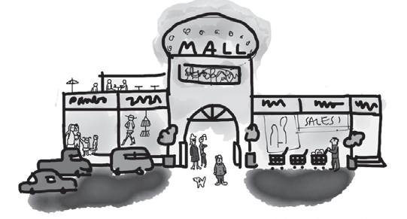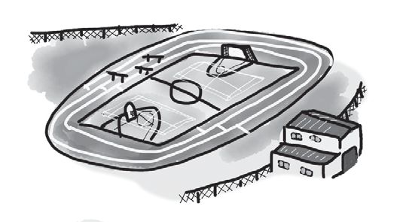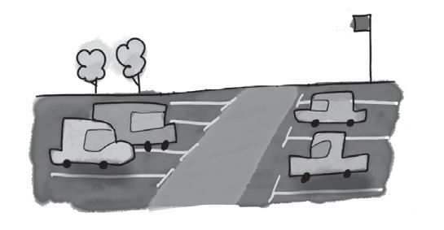
0 shopping centre 1 2

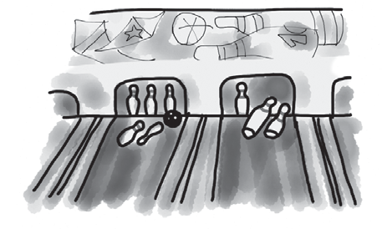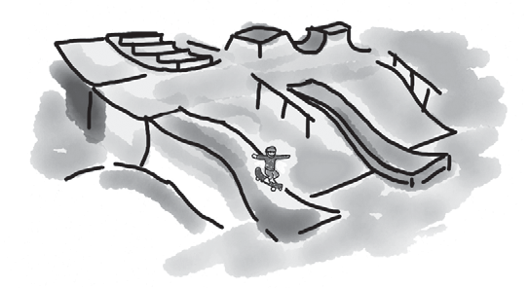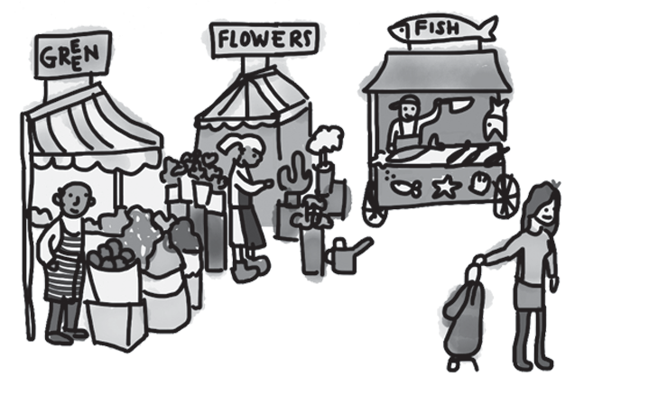
3 4 5

5

Fill in the missing words. The first letters are there to help you.
0 You can play tennis or swim at the sports centre .
- You can watch films at the c .
- You can buy fresh food at the m .
- You can watch football at the s s .
- You can see lots of old things at the m .
- You can buy everything you want or have a coffee at the s c .

5

Complete the text. The first letters are there to help you.
When you come to 0 visit my city, there are lots of ways to get around. You can put your car in a 1 c p and go on 2 f , or you can go by tram. There are lots of 3 s where you can wait for a tram. You can also go to the big bus 4 s in the centre and ask about city buses. People like the big ferry 5 p here, too. It’s really beautiful.

5

Choose the correct answer: a, b or c.
I went to the 0 centre yesterday to meet my friends. I wanted to go 1 bus, so I waited at the 2 for the bus to come. It was a very hot day – really 3 ! I met my friends for a
lemonade, and then I went to the 4 because I wanted to go swimming. After that, I walked to the 5 to buy some food and then went home.
0 | a | shopping | b | shop | c | shops
1 | a | on | b | by | c | with
2 | a | stop | b | port | c | centre
3 | a | ancient | b | boiling | c | enormous
4 | a | sports centre | b | skate park | c | bowling alley
5 | a | stadium | b | museum | c | market

5

Useful language

Complete the five conversations. Choose the correct answer: a, b or c.

0 | What did you do at the weekend, Peter? | a | I didn’t do that.
 |  | b | I went there last week.
 |  | c | I was at the skate park.
1 | I went on a ferry on Friday. | a | Do you?
 |  | b | Really?
 |  | c | Was it?
2 | My birthday party was a big surprise! | a | So you didn’t know about it?
 |  | b | What time is it?
 |  | c | Did you go to it?
3 | What did you do after the cinema? | a | The cinema was amazing!
 |  | b | We saw a really good film there.
 |  | c | We ate, then we went home.
4 | Let’s take a taxi to get to the station. | a | Yes, and then we can take a bus.
 |  | b | Yes, we took it last week.
 |  | c | Yes, it’s good to go there on foot.
5 | I did my homework at the weekend. | a | That’s brilliant.
 |  | b | That’s terrible!
 |  | c | It was amazing.

5

Listening

Listen to Joanna telling her friend Mark about her family’s trip to the city and what each person liked there. Match each person (1–5) with the place they liked (a–f).
Places they liked
0 | People  Joanna | e
1 | Ben
2 | mum
3 | dad
4 | Becky
5 | grandparents

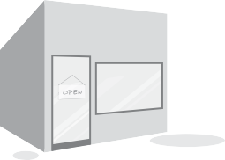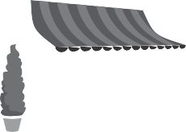a b 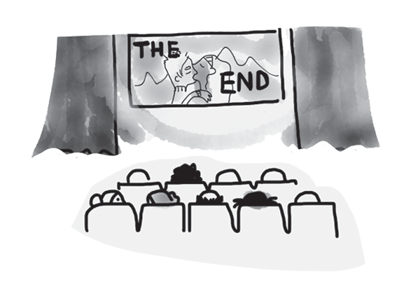
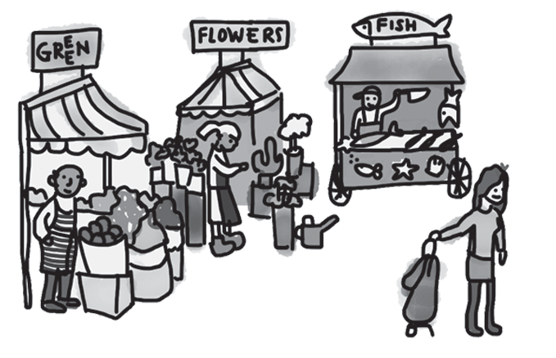c d



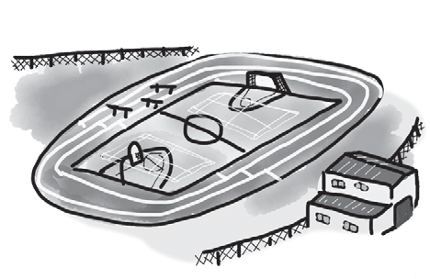e f
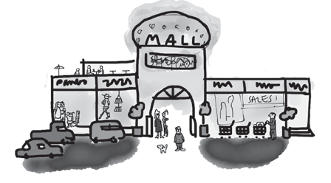

15

Reading

Read this email about Clare’s recent holiday in Prague.

Hi Rachel,
How are you? I went to Prague for a week and came back yesterday. I had a really brilliant time, and I stayed with my Czech friend, Jana. We first met last year when we studied at the same school in London.
She lives in a new house near the airport, so we took the tram to the city centre every day, and then we walked around because most of the sights are in the centre. There’s an amazing museum. That was very interesting. We saw lots of old houses in the Old Town, too. There were also lots of people there because it’s such a beautiful city.
Of course, we went shopping, too, because there are a lot of very modern shopping centres. I got a book about Prague.
I was really excited, too, because we went to the new stadium to watch AC Sparta Prague play in a match. Jana’s brother and his friend came with us. Jana and her brother love football, and it’s their favourite team.
I really want to go back again because there are so many places I didn’t visit and next time I really want to go to the zoo!
Let’s meet up soon and I can show you my photos. Love from
Clare

Answer the questions using complete sentences.
0 Where did Clare stay in Prague?
She stayed with her friend Jana.
- Where did she first meet Jana?

- Where does Jana live?

- How did they travel round the centre of Prague?

- What did Clare buy?

- Where did they watch the match?

15

Writing
- Read the email from your English friend, Alex.

From: Alex
To:

Tell me about your town. What do you do there with your friends? What are the interesting places to see? How do you travel around your town?

Write an email to Alex and answer the questions. Write 40–50 words.

15

90

Thanks and acknowledgments

We would like to thank the following for their contributions:
Sue Elliot for adapting the tests; Sarah Ackroyd & Nick Coates (Speaking) for writing the tests; Bartosz Michalowski for content and copy editing; and Jeff Zrobak for editing of proofs.

The authors and publishers are also grateful to the following contributors:
emc design ltd: develop concept design, text design and layouts Ian Harker & DSound: audio recordings
The authors and publishers acknowledge the following sources of copyright material and are grateful for the permissions granted. While every effort has been made, it has not always been possible to identify the sources of all the material used, or to trace all copyright holders. If any omissions are brought to our notice, we will be happy to include the appropriate acknowledgements on reprinting.

The publishers are grateful to the following illustrators: Anni Betts: Unit 6 Test: Extra, p. 3 (a, d); Maria Luisa Rivero: Unit 6 Test, Student A & Student B; Unit 6 Test: Extra, p. 2; Unit 6 Test: Extra, p. 3 (b, c, e, f);

