Name Class Date

Language focus

1 Put the words into the correct order to make sentences.
0 cat / sleeping / now / My / is
My cat is sleeping now.
- your / class / you / studying / in / animals / Are / Science
?
- teacher / classmates / listening / My / aren’t / the / to

- moment / I / with / am / grandparents / living / the / at / my

- photos / is / some / Jane / looking / at

- doing / now / Tom’s / are / What / brothers
?

5

2 Match the questions (1–5) with the answers (a–f).
0 Am I speaking English now? C a No, we aren’t!
- Is your brother Harry learning French? b Yes, they are.
- Are you enjoying your holiday, Ben? c Yes, you are.

- Are you and James talking?
d No, I’m not!

- Is your sister Sally studying a lot? e Yes, he is.
- Are Linda and Chris living in Madrid now? f No, she isn’t.

5

3 Complete the sentences with the correct form of the verbs in brackets. Use the present simple or present continuous.

0 Sam watches TV every evening. (watch)
- I fish and rice every day. (eat)
- What at the moment? (you / do)
- Sam French very well. (not speak)
- We History at the moment. (not study)
- Laura tennis now. (play)

5

Choose the correct answer: a, b or c.
0 Ben often to stay with his grandparents.
b

a is going
goes c going

- We sometimes a burger for lunch.
a have b are having c having
- Mum: Are you doing your homework now, Tim?
 | a they are b you are | c | I am
3 | What at school this week?
 | a you are studying b do you study | c | are you studying
4 | football at the moment?
 | a Tom is playing b Is Tom playing | c | Does Tom play
5 | Jane meat because she hates it!
 | a isn’t eating b not eating | c | doesn’t eat
Tim: Yes, .

5

Vocabulary

Label the pictures. There is one more animal name than you need.

monkey spider giraffe lion bird shark horse

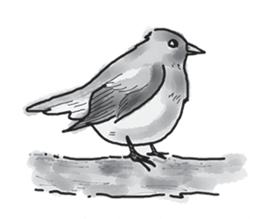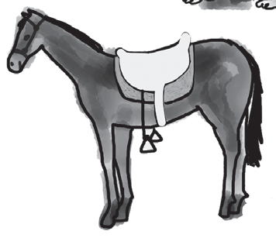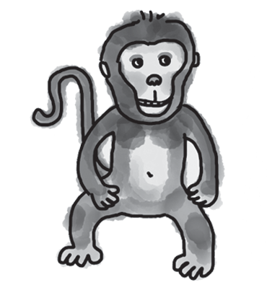
0 bird 1 2

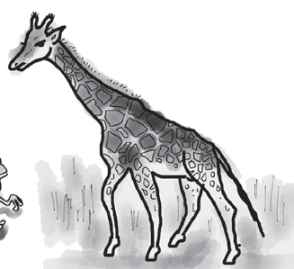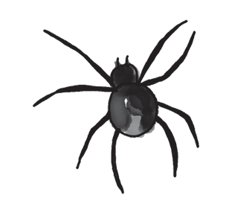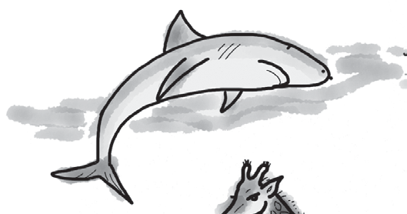
3 4 5

5

Match the descriptions (1–5) with the names of animals (a–g). There is one more name than you need.
This animal

0 | lives in trees. | f | a | camel
1 | is white and lives in cold places. |  | b | cow
2 | is very big and grey. |  | c | polar bear
3 | can live in hot, dry places. |  | d | elephant
4 | gives us milk to drink. |  | e | zebra
5 | is taller than many other animals. |  | f | monkey
 |  |  | g | giraffe

5

Underline the correct answer.
0 Some fish can swim forwards and backwards / left.
- Lions hunt / jump animals like zebras.
- Look! Those birds are swinging / ﬂying over the trees.
- Do polar bears ﬂy / swim in the sea?
- Gorillas often fight / jump other gorillas.
- Sharks can ﬂy / jump out of the water to hunt.

5

Choose the correct answer: a, b or c.
0 are my favourite animals – they’re very big and very intelligent!
c

a Fish b Sheep
Elephants

- Monkeys can backwards and forwards in the trees.
a swim b swing c ﬂy
- I really like because their very long necks are great!
a sheep b crocodiles c giraffes
- Where is the snake ? I can’t see it.
a jumping b hiding c fighting
- The shark is in the water.
a swinging b swimming c ﬂying
- are so small, but I really don’t like them!
a Spiders b Tigers c Cows

5

Useful language

Complete the conversation between Richard and a museum guide.
What does Richard say to the museum guide? Choose from the answers (a–f).

Guide: Good morning!
Richard: 0 d Guide: Yes, it is. Richard: 1
Guide: Oh, that’s easy. Walk down this hall.
Richard: 2
Guide: Then you take the stairs up to the third ﬂoor.
Richard: 3
Guide: Yes, it is. It’s on the right.
Richard: 4
Guide: It’s £3.50 for students.
Richard: 5
Guide: You’re welcome!
  - OK, thanks. Is the exhibit at the top of the stairs?
  - That’s good! How do I get to the exhibit about horses?
  - OK. Then where do I go?
  - Excuse me. Is the museum open now?
  - Great, thank you for your help.
  - And how much is a ticket for the museum?

5




Listening

You hear five people talking about different animals.
Match the name of the person (1–5) to the animal they’re describing (a–f).

People  0 Ben | c | a | Animals  zebras
1 Sophie |  | b | spiders
2 Dan |  | c | polar bears
3 Holly |  | d | sharks
4 Josh |  | e | dogs
5 Sarah |  | f | elephants

15

Reading

Read Sam’s blog.


Home
About
Posts
I’m at the zoo today because I’m doing a project on gorillas for homework. There’s a
place called Gorilla World here and lots of gorillas live in it. It’s really big!
I’m learning a lot of interesting things about these wonderful animals. One gorilla here is
1.7 m tall! I’m just 1.5 m, so he looks really big! He has got very long arms, too.
How do gorillas live in the wild? Well, they eat a lot of fruit, and the food they can ind up in the trees. They get up early (not like me!), and they look for food in the morning. Then they have a sleep at midday, and then they look for food again in the afternoon. In the evenings, they make a bed and go to sleep again.
They can live to be 45 years old in zoos. I can see four gorillas here at the moment. So I’m taking lots of photos of them. I can’t see the others. I think they’re hiding!

Are the sentences True (T) or False (F)?

0 | Sam has got some homework about gorillas. | T
1 | There aren’t many gorillas at Gorilla World.
2 | One gorilla there is bigger than Sam.
3 | Sam says gorillas hunt to get their food.
4 | Sam says gorillas sleep during the day.
5 | Sam is taking photos of all the gorillas at the zoo.

15

Writing

Write about going to an animal park. Use the questions to help you.


Is there a zoo in your town?
Do you go to animal parks? Who with? What animals can you see at the park? Which animals do you like?
Do you buy anything there?
Write 25–35 words.

15

90

Thanks and acknowledgments

We would like to thank the following for their contributions:
Sue Elliot for adapting the tests; Sarah Ackroyd & Nick Coates (Speaking) for writing the tests; Bartosz Michalowski for content and copy editing; and Jeff Zrobak for editing of proofs.

The authors and publishers are also grateful to the following contributors:
emc design ltd: develop concept design, text design and layouts Ian Harker & DSound: audio recordings
The authors and publishers acknowledge the following sources of copyright material and are grateful for the permissions granted. While every effort has been made, it has not always been possible to identify the sources of all the material used, or to trace all copyright holders. If any omissions are brought to our notice, we will be happy to include the appropriate acknowledgements on reprinting.

The publishers are grateful to the following illustrators: Maria Luisa Rivero: Unit 5 Test: Standard, p. 2.

