Name Class Date

Language focus

1 Complete the sentences with the correct form of the verbs in brackets. Use the present continuous.
0 Are you doing your homework now? (you / do)
- What today? (Jack / do)
- We a French lesson now. (not have)
- I for my History test at the moment. (study)
- Where ? (you / go)
- Emma tennis now. (not play)

5

Complete the answers to the questions.

0 | Is Jack studying in the library? | Yes, he is .
1 | Are you enjoying the film, Tom? | Yes, .
2 | Is your older brother Mark staying with you? | No, .
3 | Am I doing this right? | Yes, .
4 | Are Maria and Paul visiting the zoo today? | No, .
5 | Are you and Sally learning German? | No, .

5

Complete the sentences with the correct form of the verbs in the box. Use the present simple or present continuous.

know swing love not go listen not eat

0 Jack loves polar bears. They’re his favourite animals!
- Look! The monkeys in the trees!
- Peter meat for dinner every day. Sometimes he has fish.
- We to school this week because we’re on holiday!
- I your brothers Gary and Ben.
- Shh! I to the teacher.

5

Choose the correct answer: a, b or c.
Hi! My name’s Nat, and I ⁰ to a big school near my home. I’m very happy today! We usually 1 Maths on Wednesday mornings, but today my class 2 the zoo on a school trip! I 3 all the animals here! We 4 our lunch with us, too – sandwiches, milk and bananas! It’s a brilliant day – and we 5 a lot about animals!
0 | a | go | b | am going | c | goes
1 | a | are having | b | have | c | having
2 | a | visit | b | is visiting | c | visits
3 | a | love | b | loving | c | am loving
4 | a | are having | b | have got | c | haven’t
5 | a | learning | b | learn | c | are learning

5

Vocabulary

Label the pictures.

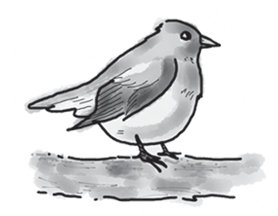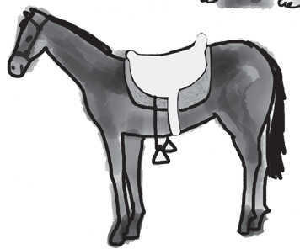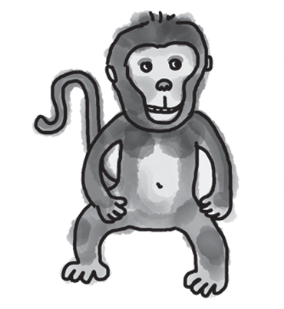
0 bird 1 2

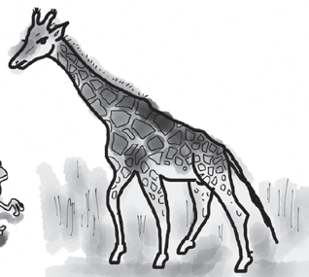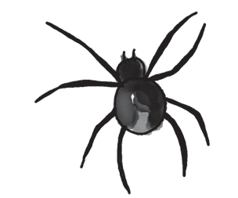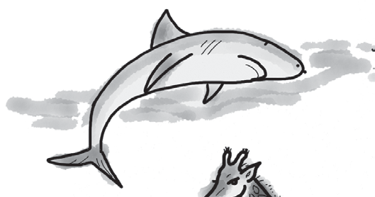
3 4 5

5

Complete the words about animals. The first letter is there to help you. There is one space for each other letter in the word.

0 | This animal lives in a cold part of the world. | p o l a r b e a r
1 | We get milk from this animal. | c
2 | This big cat is good at hunting. | t
3 | This is a very big, grey animal. | e
4 | This animal is black and white. | z
5 | This animal can get food from very tall trees! | g

5

Complete the sentences with the words from the box.

ﬂy hunt hide fight swim jump

0 Polar bears hunt for their food in the sea.
- A horse can really high.
- Birds can high over the trees.
- Monkeys often in the trees.
- Sharks in the sea.
- Lions sometimes with other lions for their food.

5

Choose the correct answer: a, b or c.
0 a spiders | b | cows | c | lions
1 a dog | b | snake | c | fish
2 a round | b | up and down | c | straight
3 a horses | b | birds | c | bears
4 a ﬂy | b | jump | c | swing
5 a hunting | b | swimming | c | hiding
My family has some animals at home because we don’t live in the town. We have two or three sheep and some 0 for milk. We also have a 1 . It’s my best friend! I get up in the morning and go for a walk with it before school. We go 2 the park and back home again. Lots of 3 live up in the tops of the trees near our house, too. They often 4 down from the tall trees into our garden. At the moment, I can’t see them. I think they’re 5 because they don’t want me to see them!
5

Useful language

Complete the five conversations. Choose the correct answer: a, b or c.

0 Where’s the zoo, please? |  | a b | Left here, then right. That’s OK.
 |  | c | Sorry, I’m afraid you can’t.
1 | How do I get to the spider exhibit? | a | Go straight down the hall.
 |  | b | Excuse me.
 |  | c | It’s very interesting!
2 | Where are the tigers? | a | Yes, they are.
 |  | b | They’re my favourites.
 |  | c | Turn left at the end of the hall.
3 | Is the snakes exhibit at the top of the stairs? | a | It’s all right.
 |  | b | Turn left here.
 |  | c | Yes, it is.
4 | The zoo’s library is on the third ﬂoor. | a | Great, thank you.
 |  | b | Yes, sure.
 |  | c | You’re welcome.
5 | Do you like going to zoos? | a | Oh, that’s easy.
 |  | b | They’re good.
 |  | c | Yes, sometimes.

5




Listening

Which animal is each speaker describing? Write the name of the animal on the line.

0  1 | Ben Sophie | polar bear
2 | Dan
3 | Holly
4 | Josh
5 | Sarah

15

Reading

Read Sam’s blog.


Home
About
Posts
I’m at the zoo today because I’m doing a project on gorillas for homework. There’s a
place called Gorilla World here and lots of gorillas live in it. It’s really big!
I’m learning a lot of interesting things about these wonderful animals. One gorilla here is
1.7 m tall! I’m just 1.5 m, so he looks really big! He has very long arms, too.
How do gorillas live in the wild? Well, they eat a lot of fruit, and the food they can find up in the trees. They get up early (not like me!), and they look for food in the morning. Then they have a sleep at midday, and then they look for food again in the afternoon. In the evenings, they make a bed and go to sleep again.
They can live to be 45 years old in zoos. I can see four gorillas here at the moment. So I’m taking lots of photos of them. I can’t see the others. I think they’re hiding!

Are the sentences True (T) or False (F)? If there isn’t enough information in the text, write Doesn’t Say (DS).
0 | Sam is at the zoo to help him with his school work. | T
1 | Not many gorillas live at the zoo.
2 | One of the gorillas has longer arms than Sam.
3 | Sam thinks the gorillas are up earlier than him in the mornings.
4 | Gorillas sleep during the afternoon.
5 | Sam can’t take photos of some of the gorillas at the zoo.

15

Writing

Read the email from your English friend, Billy.

From: Billy
To:

Do you sometimes go to the zoo? What do you do at the zoo? What animals do you like seeing there? What animals don’t you like? What do you buy at the zoo?

Write an email to Billy and answer the questions. Write 40–50 words.

15

90

Thanks and acknowledgments

We would like to thank the following for their contributions:
Sue Elliot for adapting the tests; Sarah Ackroyd & Nick Coates (Speaking) for writing the tests; Bartosz Michalowski for content and copy editing; and Jeff Zrobak for editing of proofs.

The authors and publishers are also grateful to the following contributors:
emc design ltd: develop concept design, text design and layouts Ian Harker & DSound: audio recordings
The authors and publishers acknowledge the following sources of copyright material and are grateful for the permissions granted. While every effort has been made, it has not always been possible to identify the sources of all the material used, or to trace all copyright holders. If any omissions are brought to our notice, we will be happy to include the appropriate acknowledgements on reprinting.

The publishers are grateful to the following illustrators: Maria Luisa Rivero: Unit 5 Test: Extra, p. 2.

