Name Class Date

Language focus

1 Underline the correct answer.
0 I’ve got a / some sandwich for my lunch.
- We haven’t got any / some fruit at home.
- I always have any / a drink at school in the afternoon.
- Dan has got some / any homework to do today.
- I always have an / any egg for breakfast.
- I haven’t got some / any cousins in my family.

5

2 Complete the sentences with is, are, isn’t or aren’t.
0 There aren’t any apples in my lunchbox!
- there a playing field at your school?
- There any trees my garden.
- there any sushi places in your town?
- There a new café in our town. It’s great!
- There a banana in my lunchbox because I don’t like them.

5

3 Complete the sentences with much, many or a lot of.
0 We haven’t got many eggs in the fridge.
- I eat bread every day.
- How homework do you get every day?
- There are burger bars here.
- How English classes do you have every week?
- There isn’t cheese in this pasta.

5

4 Choose the correct answer: a, b or c.
0 there a pizza place near here?
a Has b Does Is
c
- Have you got English books?
a some b a c any
- I eat a every day.
a meat b banana c bread
- I go home for lunch because there a canteen at school.
a are b is c isn’t
- I drink milk every day.
a a lot of b much c many
- A: Is there any bread for dinner?
B: Yes, .
a there is b I have c we do

5

Vocabulary

Label the pictures.

carrots fish meat cheese eggs bananas

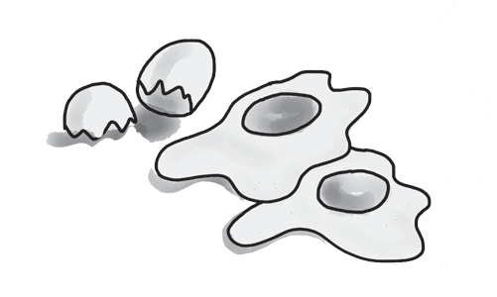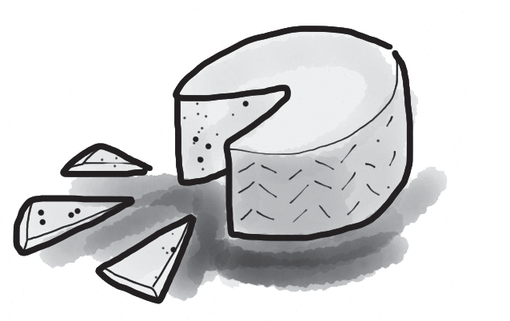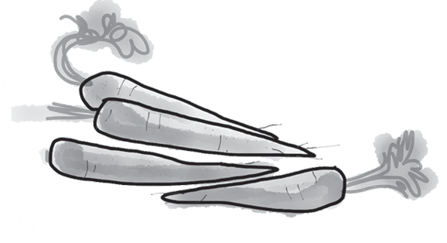
0 eggs 1 2

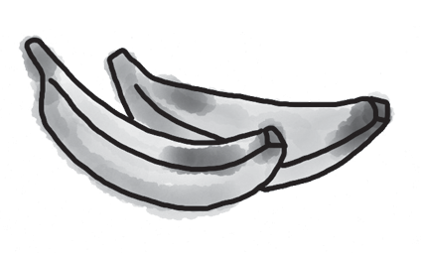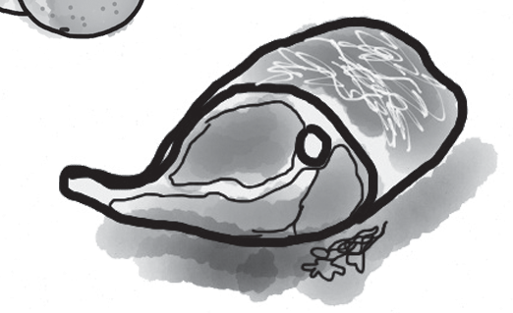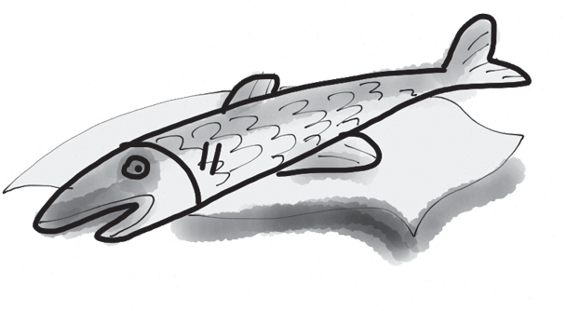
3 4 5

5

Complete the words about food. The first letter is there to help you. There is one space for each other letter in the word.
0 You can put this on bread. b u t t e r
- This is the name of some meat. c
- You put this on pasta and pizza. c
- You can eat this fruit for your dessert. b
- People eat these vegetables with meat or fish. c
- You can drink this. m

5

Complete the sentences with the words from the box.

walk dessert have dinner snack starter

0 What time do you have lunch?
- We have our at 7.30 in the evening.
- I sometimes have a in the afternoons.
- I like having a after my meal – usually an apple.
- We sometimes have fish soup as a in my house, before the main course.
- My family likes doing exercise after dinner, so we always have a .

5

Choose the correct answer: a, b or c.
0 I usually lunch at home.
b

3 I don’t eat because I don’t like bread.

a go
have c do
a pizza b rice c sandwiches

- In my family, we often eat with fish for dinner.
a rice b milk c meat
- is my favourite meat.
a Taco b Sushi c Chicken
- We usually have some apples as an afternoon .
a lunch b snack c main course
- Do you want some on your bread?
a butter b rice c pasta

5

Useful language

9 Complete the conversation between Josh and a waiter in a café. What does Josh say to the waiter? Choose the correct answers (a–f).

Waiter: Hi there! What can I get you?
Josh: 0 c
Waiter: Of course. What filling would you like?
Josh: 1
Waiter: Do you want it hot or cold?
Josh: 2
Waiter: Right. Anything to drink?
Josh: 3
Waiter: OK. Here’s your juice and your sandwich.
Josh: 4 Waiter: £2.75, please. Josh: 5 Waiter: Thank you.
- Cold, please.
- Thanks. How much is that?
- Can I have a sandwich, please?
- Here you are.
- Can I have some juice, please?
- Chicken, please – and lots of butter!

5




Listening

Listen to David and Laura talking to a waiter in a café. Underline the correct answers.
0 David thinks the café is new / old.
- David wants pasta / pizza for his lunch.
- David asks for extra cheese / meat with his meal.
- Laura wants a cheese / chicken sandwich.
- Laura wants her food to be hot / cold.
- Laura and David want juice / milk to drink.

15

Reading

Read the internet forum on food.


Teenagers talk about food
I’m from Japan, and I often eat a lot of rice
and fish. But my favourite food is Italian pizza.
I sometimes go out for a burger with my friends, too. Kyoko
My family and I eat a lot of pasta and pizza! That’s
what Italy is famous for, and the food is really brilliant. I don’t mind chicken or fish, too. Giulia
People eat quite a lot of meat in my country,
and also vegetables like carrots and beans. Our family gets them from my granddad’s garden! The food’s a bit boring – but I don’t mind it! Ben
When I go on holiday with my family, I always
have meat with rice or pasta, or burgers, but no fish. I hate it! Sarah
Everyone thinks that the Americans eat a lot
of burgers. But my family doesn’t want to eat things like that. We think chicken and fish are better. Dan
In the summer, we have a lot of cheese from all
different countries and bread. We often have meat or fish, too. My family always has lunch and dinner together, and we sometimes have snacks in the afternoon. Aphrodite

Are the sentences true (T) or false (F)?
0 Kyoko doesn’t eat meat. F
- Giulia likes eating Italian food.
- Ben hates the food from his country.

- Sarah doesn’t mind eating fish.
- Dan eats a lot of burgers.
- Aphrodite and her family like snacks.

15

Writing

Write about a family meal. Use the questions to help you.


When does your family usually eat together? How many people are there at the meal?
What do you eat?
What do you do after the meal?

Write 25–35 words.

15
90

Thanks and acknowledgments

We would like to thank the following for their contributions:
Sue Elliot for adapting the tests; Sarah Ackroyd & Nick Coates (Speaking) for writing the tests; Bartosz Michalowski for content and copy editing; and Jeff Zrobak for editing of proofs.

The authors and publishers are also grateful to the following contributors:
emc design ltd: develop concept design, text design and layouts Ian Harker & DSound: audio recordings
The authors and publishers acknowledge the following sources of copyright material and are grateful for the permissions granted. While every effort has been made, it has not always been possible to identify the sources of all the material used, or to trace all copyright holders. If any omissions are brought to our notice, we will be happy to include the appropriate acknowledgements on reprinting.

Speaking Tests: Unit 4 Tests, Student A: Alamy/©incamerastock; Unit 4 Tests, Student B: Alamy/©TongRo Images.

The publishers are grateful to the following illustrators: Maria Luisa Rivero: Unit 4 Test: Standard, p. 2.

