Name Class Date

Language focus
1 Complete the sentences with can or can’t.
0 Can you swim?
- I speak French. ✓
- I open the window?
- Simon play the guitar. ✗
- We go home now. ✓
- We use mobile phones at my school. ✗

5

2 Underline the correct answer.
0 We’ve got some new classmates at school, and I really like it / them.
- We really like our French teacher, and I think she likes them / us, too.
- Do you want to come and play tennis with her / me after school?
- Our English teacher, Mr Jones, is brilliant. I like him / us!
- Sam and Tom are our new football teammates. Do you know him / them?
- I have English on Tuesday and Friday. I really like studying it / them.

5

3 Complete the sentences with the correct form of the verbs in the box.

have do play study go listen

0 Sarah likes listening to music.
- Do you like tennis?
- I don’t like in the library.
- Jack loves swimming in the pool.
- Sam doesn’t mind his homework in the evenings.
- I hate art lessons after school.

5

4 Choose the correct answer: a, b or c.
0 Can you a bike?
c

a to ride b riding
ride

- Maria do her homework today because she does drama after school.
a can’t b isn’t c don’t
- I love tennis with my friends. It’s great!
a to play b playing c play
- Maria goes to my school. She’s my best friend and I really like .
a me b her c us
- I don’t like studying English, but Lucy really loves .
a it b them c him
- My brother doing football training. He says it’s boring!
a loves b doesn’t mind c hates

5

Vocabulary

Label the pictures.

IT room library sports hall playing field science lab canteen

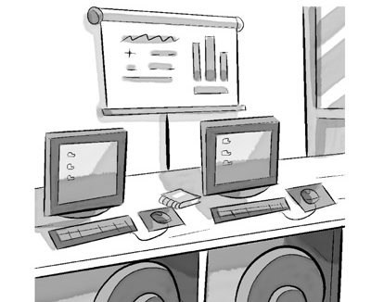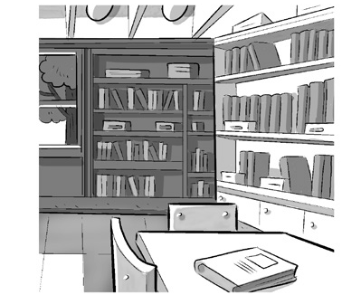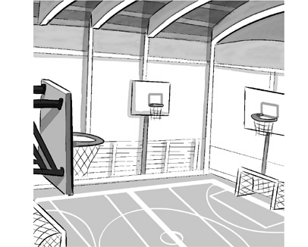
0 IT room 1 2

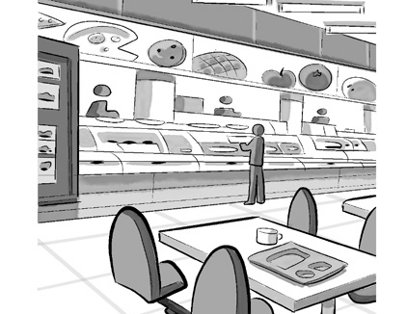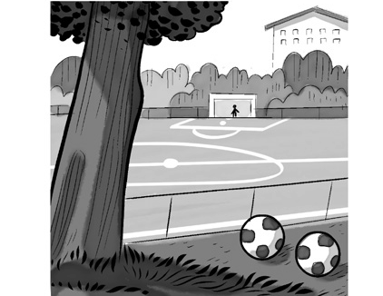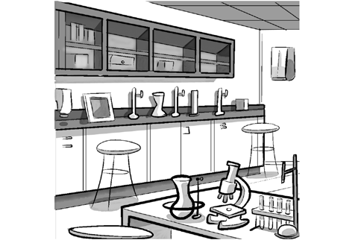
3 4 5

5

Match the descriptions (1–5) with the places in school (a–g). There is one more place than you need.
.
0 | You can use computers here. | D | a | Main hall
1 | You can have your lunch here. |  | b | Playing field
2 | You can do sports here. |  | c | Classroom
3 | You can do experiments here with your teacher. |  | d | IT room
4 | You can read and do your homework here. |  | e | Library
5 | You can have a lot of your lessons here. |  | f | Science lab

5

Complete the words about school subjects. The first letter is there to help you. There is one space for each other letter in the word.

 | 0 You need a computer to study this subject. | I C T
 | 1 You can speak to people in France in this language. | F
 | 2 This subject is about different countries. | G
 | 3 You study this subject in a lab. | S
 | 4 People in the UK speak this language. | E
8 | 5 This subject is all about numbers.  Choose the correct answer: a, b or c. | M

5

0 We use computers in the .
a main hall b canteen

IT room
c
3 I play football in the school team, and I with them on Fridays.

- We have in the sports hall on Fridays.
a Maths b Science c PE
- I’m really at singing!
a boring b terrible c slow
a practice b train c study
- We always meet in the school to have lunch.
a playing field b library c canteen
- I love studying History. It’s really .
a interesting b fast c terrible

5

Useful Language

9 Complete the conversation between Jack and his mum. What does Jack say to his mum? Choose the correct answers (a–f).

Mum: Hi, Jack. Jack: 0 e Mum: No, I’m not. Jack: 1
Mum: No, Jack, I’m afraid you can’t. Sorry!
Jack: 2
Mum: Because your grandparents are here on Friday.
Jack: 3
Mum: Yes, Jack, you can.
Jack: 4
Mum: What time is the film?
Jack: 5
Mum: OK. We can have dinner at 7 pm.
  - Can I go on Saturday then?
  - Mum, can I go to the cinema on Friday?
  - Why not?
  - Great, thanks!
  - Hi, Mum. Are you busy?
  - It’s at 4 in the afternoon.

5




Listening

Listen to different people talking about their school. Choose the correct answer: a, b or c.

0 | Which subject does Jenny really like? | a | Geography
 |  | b | ICT
 |  | c | English
1 | Simon says his PE teacher is | a | interesting.
 |  | b | great.
 |  | c | fast.
2 | Marta doesn’t like studying | a | History.
 |  | b | English.
 |  | c | ICT.
3 | Ben says his Geography class is | a | boring.
 |  | b | slow.
 |  | c | interesting.
4 | What doesn’t Angeline like about her Maths class? | a | the room
 |  | b | her classmates
 |  | c | the subject
5 | Carl has his PE class | a | after lunch.
 |  | b | in the main hall.
 |  | c | with a new sports teacher.

15

Reading

Read the article.



MY SCHOOL
My name’s Ben. I’m 11, and I go to a big school near my home. This is my first year, so everything is still quite new. I’m in Class 3A, and I’ve got 29 classmates! They’re all very friendly, but my best friend is Adam. We meet in the main hall before lessons start, and the head teacher talks to us for 15 minutes. Then we go to our classroom with our class teacher. We have lessons from 9 to 12.30, and then we have lunch.
I usually sit in the canteen with my friends and eat my sandwiches. My dad prepares them for me every morning. I don’t eat the school lunches because they’re not very good. We have three lessons in the afternoon from 1.30, and then sometimes we
do sport. Our teachers give us homework every day – I don’t really mind doing homework, and I love ICT because I like studying on my computer.

Are the sentences True (T) or False (F)?

0 | Ben’s school is quite small. | F
1 | Ben is a new student.
2 | There are 29 students in Ben’s class.
3 | The head teacher talks to them in the main hall.
4 | Ben brings his own lunch to school.
5 | Ben does sport every day.

15

Writing

Write about your school. Use the questions to help you.


Where is your school?
How many classmates do you have? What subjects do you study?
What subjects do you like?
What sports do you do at school?

Write 25–35 words.

15
90

Thanks and acknowledgments

We would like to thank the following for their contributions:
Sue Elliot for adapting the tests; Sarah Ackroyd & Nick Coates (Speaking) for writing the tests; Bartosz Michalowski for content and copy editing; and Jeff Zrobak for editing of proofs.

The authors and publishers are also grateful to the following contributors:
emc design ltd: develop concept design, text design and layouts Ian Harker & DSound: audio recordings
The authors and publishers acknowledge the following sources of copyright material and are grateful for the permissions granted. While every effort has been made, it has not always been possible to identify the sources of all the material used, or to trace all copyright holders. If any omissions are brought to our notice, we will be happy to include the appropriate acknowledgements on reprinting.

The publishers are grateful to the following illustrators: Jose Rubio: Unit 3 Test: Standard, p. 2.

