Name Class Date

Language focus

1 Write full sentences with the correct form of can.
0 I / use my mobile in class ✗ I can’t use my mobile in class.
- Laura / play tennis ✓
- I / open the window ?
- we / go into the garden today ✗
- you / speak English ?
- they / understand me ✗

5

2 Complete the sentences with the pronouns in the box. There is one more pronoun than you need.

me you him her it us them

0 My sister’s a brilliant swimmer, and I love going swimming with her .
- Luke’s my older brother. I really like !
- I usually play football on Friday. Do you want to come with ?
- My homework is terrible! I can’t do !
- Our Maths teacher is great, and he always helps .
- There are two new students in our class. Do you know ?

5

3 Write complete sentences with the verbs in the box.
Use the key to help you. Write the correct forms of the verbs.

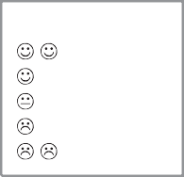
KEY
Love
like
don’t mind don’t like
hate
have play swim get up study listen

0 Jake loves swimming in the pool in the summer.
- I to music when I do my homework.
- John Maths. He thinks it’s useful.
- you football?
- John for school at 7 o’clock.
- I lunch at school.

5

Choose the correct answer: a, b or c.
Marco doesn’t mind ⁰ his homework after school. It’s usually interesting. And when he 1 do his English homework, his sister helps 2 . She loves 3 English, but she 4 Maths so Marco sometimes helps 5 . He’s faster than she is!
0 | a | do | b | doing | c | to do
1 | a | hasn’t | b | can’t | c | isn’t
2 | a | him | b | it | c | them
3 | a | study | b | studies | c | studying
4 | a | likes | b | doesn’t like | c | isn’t like
5 | a | him | b | it | c | her

5

Vocabulary

Label the pictures.

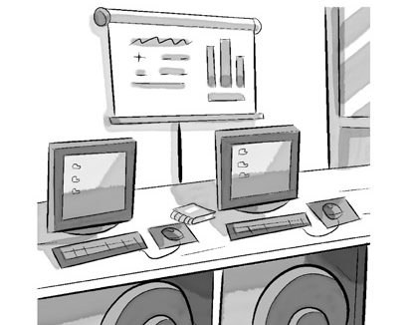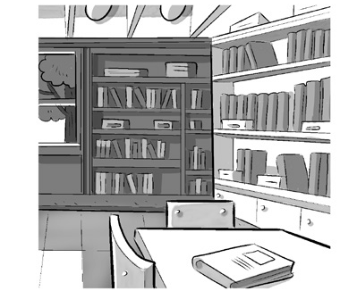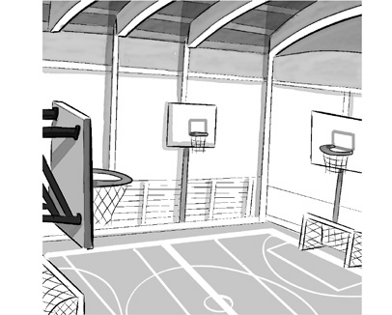
0 IT room 1 2

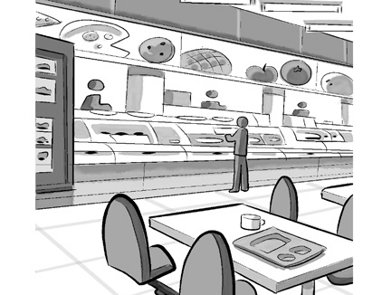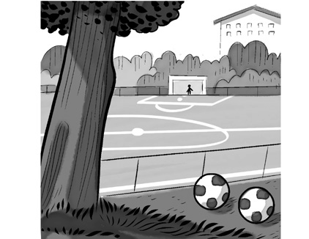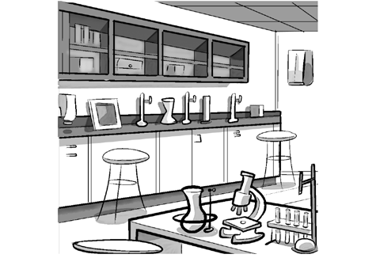
3 4 5

5

Complete the sentences. There is one space for each letter in the word.
0 We have our ICT classes in the I T r o o m .
- Everyone goes to the before lessons start.
- I always have lunch in the at school.

- We play football outside on the
.

- I love reading the books in the school .
- We do experiments in the with our Science teacher.

5

Complete the words about school subjects. The first letter is there to help you.
0 I like my English classes because my teacher is really nice, and I like reading books.
- My F lessons will be useful for my family holiday in France.
- What instruments do you play in your M lessons?
- I like studying different countries, so I love G .
- I’ve got some H homework to do about Spain 1880–1920.
- I love learning about numbers, and M lessons are really interesting for me.

5

Choose the correct answer: a, b or c.
My name’s Harry, and I go to a big school in my town. I like all my lessons there, and I really like learning 0 . That’s because I like 1 languages. My Maths teacher is 2 , too! I’m better at numbers now because I’m in his class. My favourite place at school is the 3 because I like playing football with my friends. And my favourite 4 is Science, because we do experiments in the lab, and it’s really interesting. I never go to the 5 because I have lunch at home.
0 | a | English | b | ICT | c | PE
1 | a | training | b | studying | c | having
2 | a | brilliant | b | boring | c | terrible
3 | a | classroom | b | playing field | c | IT room
4 | a | exercise | b | practice | c | subject
5 | a | canteen | b | sports hall | c | main hall

5

Useful language

Complete the five conversations. Choose the correct answer: a, b or c.

0 | Can I go to the cinema this evening? | a | That’s great!
 |  | b | Yes, we can.
 |  | c | I’m afraid you can’t.
1 | You can’t go out tomorrow. | a | It’s boring.
 |  | b | Why not?
 |  | c | Sure!
2 | Have you got some money to go out? | a | No, can I have some?
 |  | b | That’s fine.
 |  | c | Yes, it is.
3 | Can I use my mobile at school? | a | It’s not often.
 |  | b | Where is it?
 |  | c | Sorry, no.
4 | You can ask Sam to come to our house on Saturday. | a | No, they can’t!
 |  | b | Great, thanks!
 |  | c | That’s terrible!
5 | Can you play football at school on Monday? | a | It’s interesting.
 |  | b | Where is that?
 |  | c | Sorry, I can’t.

5




Listening

Listen to five people talking about their school. Match the person (1–5) with what they say (a–f).

Person  0 Jenny | c | a | What they say  My class is really interesting.
1 Simon |  | b | I have a new teacher.
2 Marta |  | c | I have help with my homework.
3 Ben |  | d | I don’t like my classroom.
4 Angeline |  | e | I really like my computer class.
5 Carl |  | f | My teacher is very nice.

15

Reading

Read the article.



MY SCHOOL
My name’s Ben. I’m 11, and I go to a big school near my home. This is my first year, so everything is still quite new. I’m in Class 3A, and I’ve got 29 classmates! They’re all very friendly, but my best friend is Adam. We meet in the main hall before lessons start, and the head teacher talks to us for 15 minutes. Then we go to our classroom with our class teacher. We have lessons from 9 to 12.30, and then we have lunch. I usually sit in the canteen with my friends and eat my sandwiches. My dad prepares them for me every morning. I don’t eat the school lunches because they’re not very good. We have three lessons in the afternoon from 1.30, and then sometimes we do sport. Our teachers give us homework every day – I don’t really mind doing homework, and I love ICT because I like studying on my computer.

Answer the questions in complete sentences.

Writing
0 | How old is Ben? | He’s 11 years old.
1 | Where does Ben go to school?
2 | Where does he meet his classmates?
3 | Where does he have his lunch?
4 | When do lessons start after lunch?
5 | How often does he get homework?

15

Read the email from your English friend, Sam.

From: Sam
To:

I know you’re at your new school now. Tell me all about it! What’s your favourite subject? Is there a subject that you don’t like? What’s your favourite place in the school? And what time do you have lunch?

Write an email to Sam and answer the questions. Write 40–50 words.

15

90

Thanks and acknowledgments

We would like to thank the following for their contributions:
Sue Elliot for adapting the tests; Sarah Ackroyd & Nick Coates (Speaking) for writing the tests; Bartosz Michalowski for content and copy editing; and Jeff Zrobak for editing of proofs.

The authors and publishers are also grateful to the following contributors:
emc design ltd: develop concept design, text design and layouts Ian Harker & DSound: audio recordings
The authors and publishers acknowledge the following sources of copyright material and are grateful for the permissions granted. While every effort has been made, it has not always been possible to identify the sources of all the material used, or to trace all copyright holders. If any omissions are brought to our notice, we will be happy to include the appropriate acknowledgements on reprinting.

The publishers are grateful to the following illustrators: Jose Rubio: Unit 3 Test: Extra, p. 2.

