Name Class Date

Language focus

1 Complete the sentences with the correct form of the verbs in brackets. Use the present simple.
0 Jack goes (go) to school at 7.30 in the morning.
- Peter (not like) football. He likes tennis.
- My mum (teach) at my school. My classmates all like her.
- I (not have) lunch at school. I go home to eat.
- My brother (study) Spanish at university. He’s got a good teacher.
- My dad (watch) TV in the evenings.

5

2 Underline the correct answer.
0 A: Does Adam study English?
B: Yes, he does / is.
- What / When do you do your homework?
- A: Do you like school?
B: No, I doesn’t / don’t.
- Where / What does Stephen do at school?
- What time / What does our art class start?
- Does / Do your sister walk to school with you?

5

3 Write the sentences with the adverbs in the correct place.
0 I’m busy at the weekends. (always)
I’m always busy at the weekends.
- I do my homework in the mornings. (sometimes)

- Tom is happy at school. (always)

- We go out with our friends at the weekend. (often)

- My parents are tired on Friday evening. (usually)

- My brother does sport on Saturdays. (never)

5

4 Choose the correct answer: a, b or c.
0 Where your older sister study?

3 A: Does Emily live in a big city?

a do b is
c
- Ben do his homework every day.
does
B: Yes, she .
a does b do c is

a don’t b doesn’t c isn’t
- does our lesson start in Room B15?
a Where b How often c What time
- do you usually have lunch with?
a What b Who c Where
- My parents to work very early.
a doesn’t go b goes c go

5

Vocabulary

Label the pictures.

brush my teeth do my homework go to bed do some exercise have lunch have a shower

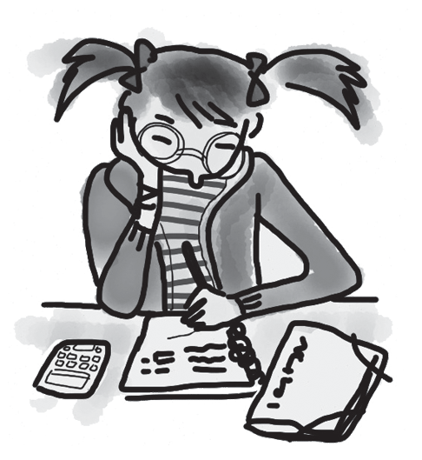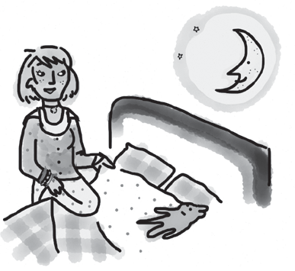
0 do my homework 1 2

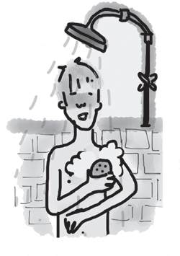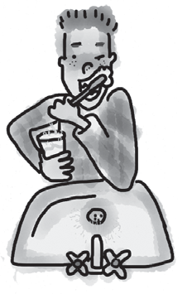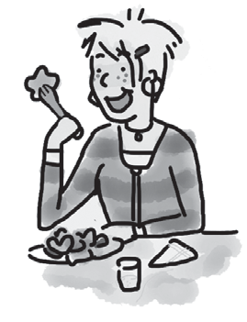
3 4 5

5

Complete the verbs. The first letter is there to help you. There is one space for each other letter in the word.

0 I g e t up at 7 o’clock.
- I usually h breakfast at 7.10.
- I g dressed after my shower.
- I w to school with my friend.
- I s school at 8 o’clock in the morning.
- I g to bed at 9.30 pm in the evening.

5

Underline the correct answer.
0 I often play / go music on Saturday mornings.
- Where do you play / do karate?
- I sometimes go / play swimming at the weekend.
- I don’t play / go chess.
- We all do / play drama on Thursdays after school.
- I go / have a dance class every Friday.

5

Choose the correct answer: a, b or c.
0 We sometimes go at the weekend. swimming b dance classes c football
a
- My mum music classes at the local college.
a goes b plays c has
- I don’t breakfast every day.
a have b go c do

- I sometimes play with my friends after school.
a drama b karate c chess
- I usually eat with my classmates lunchtime.
a in b at c at the
- Do you have a in the afternoons after school?
a dinner b snack c lunch

5

Useful language

9 Complete the conversation between two students. What does Naomi say to Max? Choose from the answers (a–f).

Max: Hi. Are you lost?
Naomi: 0 e
Max: Really? Can I help?
Naomi: 1
Max: Yes, sure. I do drama. But it isn’t on today.
Naomi: 2
Max: It’s on Thursday, in the evening.
Naomi: 3
Max: It’s at 7 o’clock.
Naomi: 4
Max: It’s £3 a lesson.
Naomi: 5
Max: Yes, of course you can! Meet me at the swimming pool at 6.45 on Thursday.
Naomi: Great!
  - Right … And how much does it cost?
  - Well, do you know about the drama classes?
  - Oh! What day is the class?
  - I’d really like to go. Can I go with you?
  - Yes, I am. I’m new at this school.
  - And what time is the class?

5




Listening

Listen to Mark and Linda talking about what they do on school days. Choose the correct answer: a or b.

0 | This person does their homework after school. | a | Mark
 |  | b | Linda
1 | This person doesn’t like school. | a | Mark
 |  | b | Linda
2 | This person is usually at school at 8.15. | a | Mark
 |  | b | Linda
3 | This person likes English. | a | Mark
 |  | b | Linda
4 | This person has drama classes. | a | Mark
 |  | b | Linda
5 | This person plays chess. | a | Mark
 |  | b | Linda

15

Reading

Read Anna’s blog.


Home
About
Posts
Hi, my name’s Anna, and I live in Bristol with my parents and my two sisters.
I go to a school near my home. I get up at 7 o’clock, and then I have a shower, have breakfast and do my homework. School starts at 8.30, and the first lesson is at 9 o’clock. We have four lessons in the morning, and then we have lunch. After lunch, we have more lessons, and we go home at 3.30. On Mondays and Wednesdays, I play tennis, and on Tuesdays,
I go swimming. I like sport, but my sisters don’t. They like books and computer games. At the weekend, I often go out with friends, and then it’s Monday again!

Are the sentences True (T) or False (F)?

0 | There are four people in Anna’s family. | F
1 | Anna lives near her school.
2 | Anna does her homework in the evening.
3 | Anna is at school from 8.30 until 3.30.
4 | Anna plays tennis with her sisters.
5 | Anna sees her friends on Saturday and Sunday.

15

Writing

Write about what you do on a school day. Use the questions to help you.


What time do you get up?
What time do you have breakfast? Where is your school?
Where do you have lunch?
When do you do your homework? What do you do in the evenings?

Write 25–35 words.

15

90

Thanks and acknowledgments

We would like to thank the following for their contributions:
Sue Elliot for adapting the tests; Sarah Ackroyd & Nick Coates (Speaking) for writing the tests; Bartosz Michalowski for content and copy editing; and Jeff Zrobak for editing of proofs.

The authors and publishers are also grateful to the following contributors:
emc design ltd: develop concept design, text design and layouts Ian Harker & DSound: audio recordings
The authors and publishers acknowledge the following sources of copyright material and are grateful for the permissions granted. While every effort has been made, it has not always been possible to identify the sources of all the material used, or to trace all copyright holders. If any omissions are brought to our notice, we will be happy to include the appropriate acknowledgements on reprinting.

Speaking Tests: Unit 2 Test, Student B: Alamy/©D. Hurst.

The publishers are grateful to the following illustrators: Maria Luisa Rivero: Unit 2 Test, Student A; Unit 2 Test: Standard, p. 2.

