Name Class Date

Language focus

1 Complete the sentences with the correct form of the verbs in the box.

start do have go teach get up

0 Sally always gets up at 7 o’clock. (+)
- I my homework every day. (–)
- Mr Harris English at after school classes. (+)
- We to bed late at the weekend. (+)
- Peter a shower in the evening. (–)
- Our English class at 9 o’clock every morning. (+)

5

- Write questions that fit the answers. Use the correct question words: what, where, when or how often.

0 | time / you / start school?  What time do you start school? | I start school at 8.30 am.
1 | Tom / live?
 |  | He lives in a house with a big garden.
2 | you / play tennis?
 |  | I play tennis in the evenings.
3 | Louise / go / to school?
 |  | She goes to a big school in her town.
4 | time / your English class / start?
 |  | It starts at 9.45 in the morning.
5 | you / watch TV / in bed ?
 |  | I always watch TV in bed on Saturday mornings.

5

Put the words into the correct order to make sentences.
0 usually / breakfast / have / 7.30 / at / I
I usually have breakfast at 7.30.
- at / brother / does / weekend / always / sport / the / My

- Mondays / usually / We / on / class / our / have / English

- with / sometimes / lunch / Emma / friends / has

- evening / am / tired / usually / I / Friday / on

- school / never / homework / Daniel / after / his / does

5
4 Choose the correct answer: a, b or c.
My name’s Jack, and I ⁰ with my parents in London. My father 1 at my school. I see him there every day, but I 2 say hello! After school, I 3 do my homework in the evening, because I don’t have time in the mornings. I like drama, too, but I don’t often 4 drama classes in the evenings. They’re usually at the weekends. What about you? 5 do you do after school?
0 | a | live | b | living | c | lives
1 | a | teach | b | not teach | c | teaches
2 | a | don’t | b | doesn’t | c | am not
3 | a | never | b | sometimes | c | always
4 | a | having | b | have | c | haven’t
5 | a | What | b | When | c | Where

5

5

Vocabulary

Label the pictures.
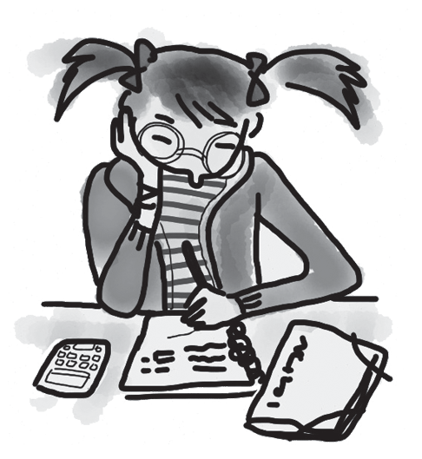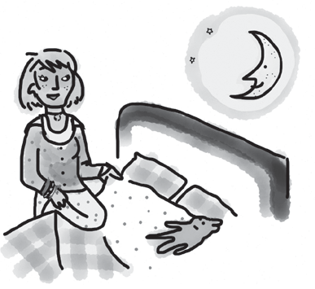
0 do my homework 1 2

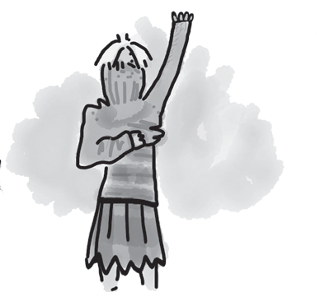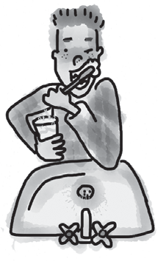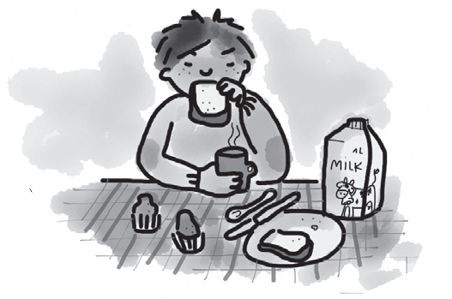
3 4 5

5

Fill in the missing verbs.
0 I get up at 7.00 am every school day.
- I school at 8.30 in the morning.
- I football with my friends at lunchtime.

- I usually a snack after school.
- I sometimes TV in the evenings.
- I usually to bed at 10 pm.

5

7 Complete the sentences with the words from the box.

art swimming chess football music karate

0 My brother sometimes plays chess with my granddad in the evenings.
- I never go because I don’t like water.
- We usually have classes on Monday afternoon.
- My brother plays wonderful on his guitar.
- I play with my teammates at the weekend.
- Does Hannah do after school?

5

8 Choose the correct answer: a, b or c.
Harry is my younger brother. He always 0 up late, and he never has breakfast in the 1 before he goes to school because there’s no time. When he gets home, he has a 2 and then plays 3 with his friends. He also does 4 on Saturday mornings and goes swimming in the afternoon. Harry always sleeps well 5 night!
5
0  1 | a a | goes afternoon | b b | gets evening | c c | is morning
2 | a | drink | b | lunch | c | dinner
3 | a | drama | b | football | c | swimming
4 | a | karate | b | tennis | c | chess
5 | a | on | b | at | c | in

Useful language

9 Complete the five conversations. Choose the correct answer: a, b or c.

5
0 | Hi! Are you lost? | a | It’s bad.
 |  | b | Yes, I am.
 |  | c | Can I help you?
1 | What do you do after school? | a | Have we got homework?
 |  | b | I play football.
 |  | c | Yes, I do.
2 | Do you know about karate classes? | a | Yes, sure!
 |  | b | That’s fine.
 |  | c | It’s not there.
3 | Can I come to your dance class with you? | a | That’s right.
 |  | b | I like my dance class.
 |  | c | Yes, you can.
4 | How much does it cost to go swimming? | a | It’s at 3.30 pm.
 |  | b | It’s £2.50 a day.
 |  | c | It’s after school.
5 | What day is the drama class? | a | Monday lunchtime.
 |  | b | I’d like to go.
 |  | c | In the sports hall.




Listening

Listen to Mark and Linda talking about what they do on school days.

Fill in the missing information.
0 Linda does her homework after school .
- Mark does his homework in .
- Mark gets up at .
- At school, Mark likes .
- Linda does classes in the evenings.
- Mark plays chess with his .

15

Reading

Read Anna’s blog.


Home
About
Posts
Hi, my name’s Anna, and I live in Bristol with my parents and my two sisters.
I go to a school near my home. I get up at 7 o’clock in the mornings, and then I have a shower, have breakfast and do my homework. School starts at 8.30, and the first lesson is at 9 o’clock – usually Maths or English. We have four lessons in the morning, and then we have our lunch. We don’t go home because after lunch we have more lessons. School finishes at 3.30, and I usually go home and have a snack and a drink. On Mondays and Wednesdays, I play tennis, and on Tuesdays, I go swimming. I like sport, but my sisters don’t. They like books and computer games. At the weekend, I often go out with friends, and then it’s Monday again!

Are the sentences True (T) or False (F)? If there isn’t enough information in the text, write Doesn’t Say (DS).
15
0 | There are five people in Anna’s family. | T
1 | Anna goes to school with her sisters.
2 | Anna lives near her school.
3 | Anna has four lessons after lunch.
4 | Anna has a snack at school in the afternoon.
5 | Anna does sport on three days in the week.

Writing

Read the email from your Canadian friend, Jo.

From: Jo
To:

I’m busy every day at school! Tell me about your school day! What do you do at home in the mornings? What do you do at school? Do you get a lot of homework?

Write an email to Jo and answer the questions.
Write 40–50 words.

15

90

Thanks and acknowledgments

We would like to thank the following for their contributions:
Sue Elliot for adapting the tests; Sarah Ackroyd & Nick Coates (Speaking) for writing the tests; Bartosz Michalowski for content and copy editing; and Jeff Zrobak for editing of proofs.

The authors and publishers are also grateful to the following contributors:
emc design ltd: develop concept design, text design and layouts Ian Harker & DSound: audio recordings
The authors and publishers acknowledge the following sources of copyright material and are grateful for the permissions granted. While every effort has been made, it has not always been possible to identify the sources of all the material used, or to trace all copyright holders. If any omissions are brought to our notice, we will be happy to include the appropriate acknowledgements on reprinting.

Speaking Tests: Unit 2 Test, Student B: Alamy/©D. Hurst.

The publishers are grateful to the following illustrators: Maria Luisa Rivero: Unit 2 Test, Student A; Unit 2 Test: Extra, p. 2.

