Name Class Date

Language focus

Complete the sentences with the correct form of have got.
Ben lives with his parents and his older brother Jon. They 0 ’ve got a house in the city. Ben 1 a big garden to play in – his garden is quite small, but Ben likes it. His mum 2 a job at his school. She’s a teacher there, and his dad works at home. Ben and his brother 3 a computer, but they can use their dad’s. Ben 4 a lot of games, and he likes playing them with Jon. Ben and Jon 5 guitars, too, and they play music with their friends after school.

5

Complete the answers to the questions.

0 | Have you got an MP3 player? | Yes, I have .
1 | Is your sister taller than you? | No, .
2 | Have Luke and his family got a big garden? | No, .
3 | Has Maria got a better skateboard than you? | Yes, .
4 | Have we got a new English teacher this year? | No, .
5 | Is your dog very intelligent? | Yes, !

5

Complete the sentences with the correct form of the words in brackets.
My name is Sarah, and I’ve got a sister called Marta. She’s 0younger (young) than me. I’m 13 and she’s 11. We live with our parents in a really nice house. Our garden is great, too –
the trees in it are 1 (tall) than the trees in any other gardens in our street. My room is 2 (big) than Marta’s. Her room is quite small, but it’s 3 (colourful) than my room – it’s yellow and blue! On Saturdays we go to a singing class, and then take our skateboards to the park. Marta is 4 (good) than I am on a skateboard – but she’s a 5 (bad) singer than me!

5

Choose the correct answer: a, b or c.
0 your sister taller than you?
a Is b Has c Does
- I think I’m than my brother!
a funny b funnier c more funny
- In my room I’ve got a guitar, but I a computer.
a haven’t got b have got c hasn’t got
- A: Has Philip got blue eyes?
B: Yes, .
a he is b he does c he has
- My hair is darker your hair.
a then b that c than
- We a lot of wonderful trees in our garden.
a ’ve got b ’ve c got

5

Vocabulary

Complete the family tree. The first letter is there to help you.

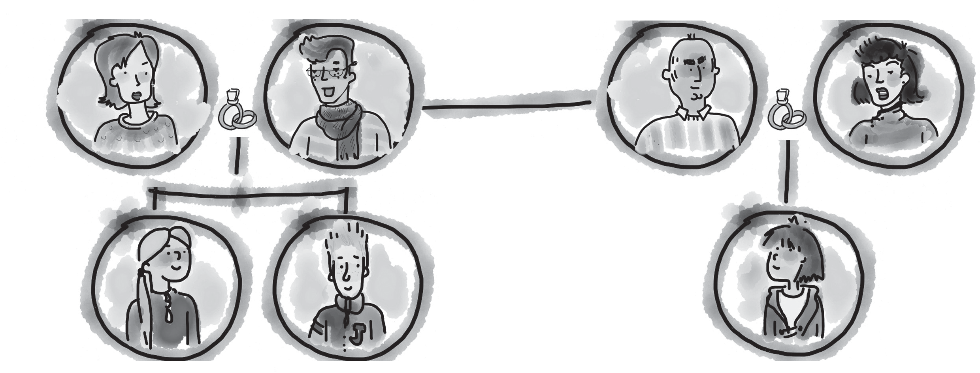
0 mum
1 d
2 u
00 aunt
3 s
4 b
5 c
- Complete the sentences.
5
0 My mum and dad are my parents .
- My uncle’s children are my .
- My dad’s dad is my .
- I have lessons at school with my .
- My dad is my cousin’s .
- My uncle’s wife is my .

5

Complete the words. You have the first letter to help you. There is one space for each other letter in the word.
0 My sister is three months old. She’s very y o u n g .
- Stella’s brother is tall, with dark hair. He’s very g -l .
- My hair isn’t curly. It’s s .
- My hair is short, but my best friend’s hair is l .
- I can do my homework on my computer and play games, too. It’s very u .
- My big garden is wonderful, with some unusual tall trees in it. It’s a b garden.

5

Choose the correct answer: a, b or c.
Hi! I’m Danni, and my mum and dad are called Jack and Karen. There are 0 children in our family. My 1 is called Tom, and my sister’s name is Maria. Tom’s older than us, and he’s very funny! And Maria’s very pretty. It’s quite a small family, but we’ve got a lot of 2 in Australia. They’re very 3 there. We don’t really look the same. Our parents have both got fair hair. Tom and I have got short 4 dark hair, but Maria’s hair is fair, like Mum and Dad. Maria and I are 5 than Tom. He’s 147 cm tall, but we’re both 135 cm.

0 | a | two | b | three | c | four
1 | a | brother | b | best friend | c | uncle
2 | a | grandparents | b | cousins | c | parents
3 | a | lucky | b | happy | c | usual
4 | a | long | b | spiky | c | tall
5 | a | longer | b | bigger | c | shorter

5

Useful language

Complete the five conversations. Choose the correct answer: a, b or c.

0 | Hi, it’s Sam. | a | He’s not here.
 |  | b | Hello, Sam.
 |  | c | It’s OK.
1 | What’s your phone number? | a | It’s 216 384.
 |  | b | 2 pm.
 |  | c | Yes, it is.
2 | Can I speak to Jack, please? | a | Bye.
 |  | b | Just a minute.
 |  | c | I haven’t got it.
3 | Can I call you back? | a | That’s good.
 |  | b | I’m fine, thanks.
 |  | c | Yes, talk to you later.
4 | Hello? | a | Hi, it’s Karl.
 |  | b | What’s your number?
 |  | c | Sure, that’s fine.
5 | Can you email me? | a | It’s lydia@postmail.com.
 |  | b | OK, thanks.
 |  | c | What’s your address?

5




Listening

You hear a girl called Steffie talking about the people she knows. What does she say about each person? Choose the correct answer: a, b or c.

0 | What does Steffie say about Tim? | a | He’s got long hair.
 |  | b | He’s short.
 |  | c | He’s got blue eyes.
1 | Steffie’s aunt Emma is | a | tall.
 |  | b | pretty.
 |  | c | old.
2 | Julia is Steffie’s | a | teammate.
 |  | b | best friend.
 |  | c | classmate.
3 | What does Steffie say about David? | a | He’s nice.
 |  | b | He’s got short hair.
 |  | c | He’s young.
4 | Who is Harry? | a | Steffie’s dad.
 |  | b | Steffie’s uncle.
 |  | c | Steffie’s brother.
5 | Steffie’s cousin Joe is | a | younger than Steffie.
 |  | b | taller than Steffie.
 |  | c | older than Steffie.

15

Reading


Read the text.

Myfamily
Hi everyone! My name’s Lucy. Myfamily isn’t very big. I’ve got a brother and asister. My brother’s name is Josh. He’s 15 years old, and he’s very tall. He’s got big green eyes and dark curly hair. Mysister’s name is Ellie, and she’s 10 years old. She’squite short and has got long dark straight hair. I’m in the middle. I’m 13 years old, and I’m quite tall. I’ve got short hair and blue eyes. Ourparents are 40, and they’re both teachers at my school. Mum hasn’t got brothers or sisters, but Dad’s brother is a Maths teacher at the same school and hiswife is ateacher, too. They’ve got three children. They’re all at university in another city.

Answer the questions in complete sentences.

0 | Has Lucy got a big or a small family? | She’s got a small family.
1 | Who is Josh?
2 | Is Ellie tall or short?
3 | How old is Lucy?
4 | What is her uncle’s job?
5 | Where are Lucy’s cousins?

15

Writing

Read the email from your American friend, Alex.

From: Alex
To:

I’ve got a great best friend called Sam. What’s your best friend’s name? Where is he or she from? What does your friend look like? What about your friend’s family? Tell me all about your best friend!

Write an email to Alex and answer the questions. Write 40–50 words.

15

90

Thanks and acknowledgments

We would like to thank the following for their contributions:
Sue Elliot for adapting the tests; Sarah Ackroyd & Nick Coates (Speaking) for writing the tests; Bartosz Michalowski for content and copy editing; and Jeff Zrobak for editing of proofs.

The authors and publishers are also grateful to the following contributors:
emc design ltd: develop concept design, text design and layouts Ian Harker & DSound: audio recordings
The authors and publishers acknowledge the following sources of copyright material and are grateful for the permissions granted. While every effort has been made, it has not always been possible to identify the sources of all the material used, or to trace all copyright holders. If any omissions are brought to our notice, we will be happy to include the appropriate acknowledgements on reprinting.

The publishers are grateful to the following illustrators: Maria Luisa Rivero: Unit 1 Test: Extra, p. 2.

