Name Class Date

Language focus

1 Complete the sentences with the correct preposition.
0

in front of behind on between next to in


1
2
3











0 The book is on the bag.
4
5
- The book is the laptop.
- The book is the bag.
- The book is the bag and the laptop.
- The book is the bag.
- The book is the bag.

5

2 Complete the sentences with the correct positive or negative form of the verb be.
0 Hi! I’m Jack.
- You Sarah. Hi, Sarah!
- We at school today. It’s a holiday!
- I cold. It’s hot in the classroom.
- Our teacher from the UK. He’s British.
- The bag blue. It’s red.

5

Match the questions (1–5) with the answers (a–f).

0 | Are your parents here? | e | a | Yes, it is.
1 | Is Peter your brother? |  | b | No, we aren’t.
2 | Is it a hot day today? |  | c | No, I’m not.
3 | Are you from Spain, Tim? |  | d | Yes, she is.
4 | Is Sarah your sister? |  | e | Yes, they are.
5 | Are you and Sam students? |  | f | No, he isn’t.

5

Underline the correct answer.
0 Kate, is that your / her sister over there?
- I have two brothers. Their / Our names are Jack and Tom.
- We’re from London, and her / our house is big.
- This is Sally, and that’s their / her sister Lucy.
- Sam’s from Brazil but his / your parents aren’t Brazilian.
- This is my / your friend. His name is Tom.

5

5 Complete the sentences with possessive pronouns. The first letter is there to help you.
0 This is my book. It’s mine .
- That’s Adam’s phone. It’s h .
- This is my sister’s room. It’s h .
- They’re my brothers’ bikes. They’re t .
- These are our bags. They’re .
- This is your pen. It’s y .

5

Use these words to make sentences. Use the possessive ’s and is/are.
0 my mum / phone / red
My mum’s phone is red.
- Kate / computer / new

- Harry / cats / big

- Jack / friends / nice

- my dad / car / old

- my brother / skateboard / blue

5

Underline the correct answer.
0 This / These is my house.
- Please can I see this / that English book over there?
- Do you want this / these pens?
- I like those / that shoes.
- Those / These exercises here aren’t very difficult.
- This / Those is my bag.

5

Match the questions (1–5) with answers (a–f).

0 How are you? | e | a | On the chair.
1 What’s your name? |  | b | 11.30.
2 Where are you from? |  | c | It’s Ben.
3 How old are you? |  | d | Italy.
4 What time is it now? |  | e | Fine, thanks.
5 Where is the book? |  | f | 15.

5

Vocabulary

Complete the calculations. Write the answers in words.
0 2 + 6 = eight
1 10 ÷ 2 =
2 18 – 7 =
3 9 x 2 =
4 8 + 4 =
5 5 x 3 =

5

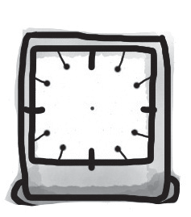
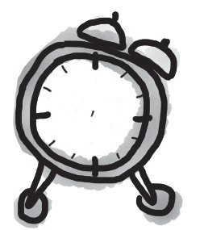
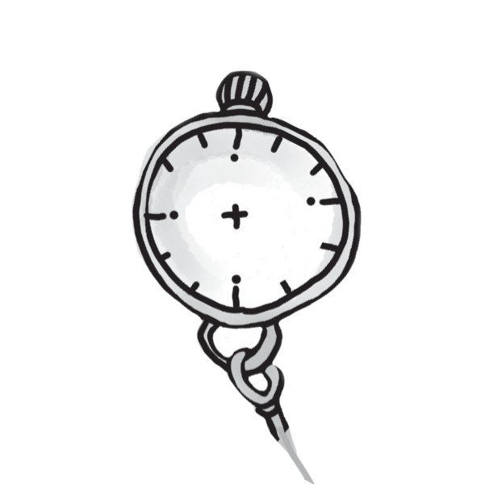
Draw the times on the clocks.
1
0
3
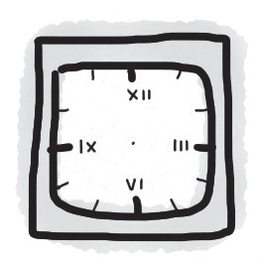
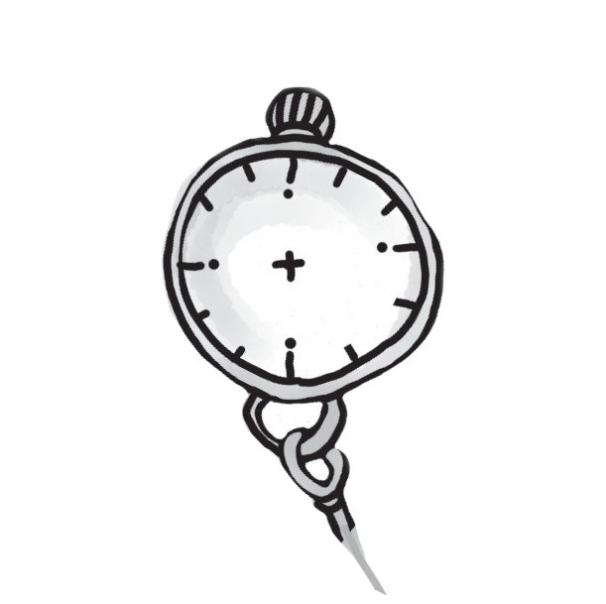
0 half past three
5
2
5
- a quarter past five
- twelve o’clock
- a quarter to eleven
- ten past four
- seven o’clock

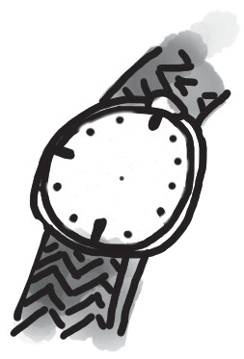
4

Label the classroom objects.

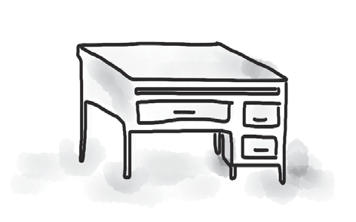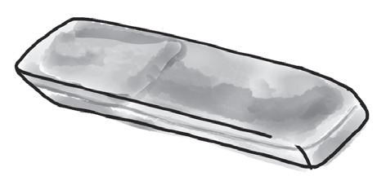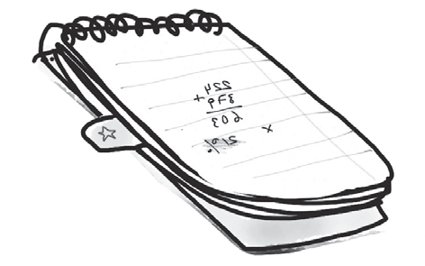
0 desk 1 2

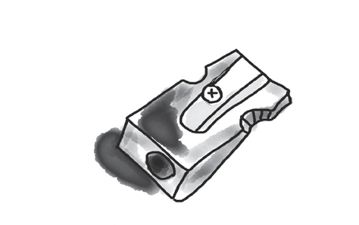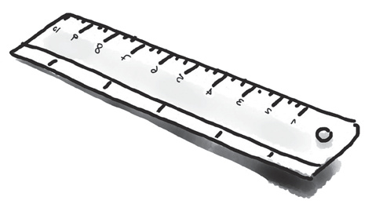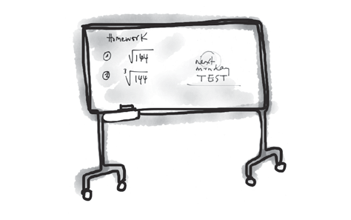
3 4 5

5

Complete the sentences with the words from the box.

car skateboards laptop dictionary bike mobile phone

0 Is that your English dictionary ?
- I do my school work on my new . It’s great!
- I go to school on my old .
- I want a new to call my friends. It’s very expensive!
- On cold days, I go to school in Mum’s small .
- On Saturdays, my friends and I play on our .

5

Complete the words to make the names of days of the week. There are some letters there to help you. There is one space for each other letter in the word.
0 T h u r s day
1 W day
- F day
- S day
- T day
- M day

5

Complete the names of the months. The first letter is there to help you. There is one space for each other letter in the word.
0 This is the month before June. M a y
- This is the 1st month of the year. J
- This is the month after August. S
- This is the 2nd month of the year. F
- This is the last month of the year. D
- This is the 11th month of the year. N

5

Complete the sentences with the name of the language. The first letter is there to help you.
0 I’m from China and I speak Chinese .
- I’m from Russia and I speak R .
- I’m from Japan and I speak J .
- I’m from Turkey and I speak T .
- I’m from Spain and I speak S .
- I’m from France and I speak F .

5

75

Thanks and acknowledgments

We would like to thank the following for their contributions:
Sue Elliot for adapting the tests; Sarah Ackroyd & Nick Coates (Speaking) for writing the tests; Bartosz Michalowski for content and copy editing; and Jeff Zrobak for editing of proofs.

The authors and publishers are also grateful to the following contributors:
emc design ltd: develop concept design, text design and layouts Ian Harker & DSound: audio recordings
The authors and publishers acknowledge the following sources of copyright material and are grateful for the permissions granted. While every effort has been made, it has not always been possible to identify the sources of all the material used, or to trace all copyright holders. If any omissions are brought to our notice, we will be happy to include the appropriate acknowledgements on reprinting.

The publishers are grateful to the following illustrators: Anni Betts: Diagnostic Test
p. 1; Maria Luisa Rivero: Diagnostic Test p. 3; Diagnostic Test – Answer Key, Vocabulary, Ex. 10.

